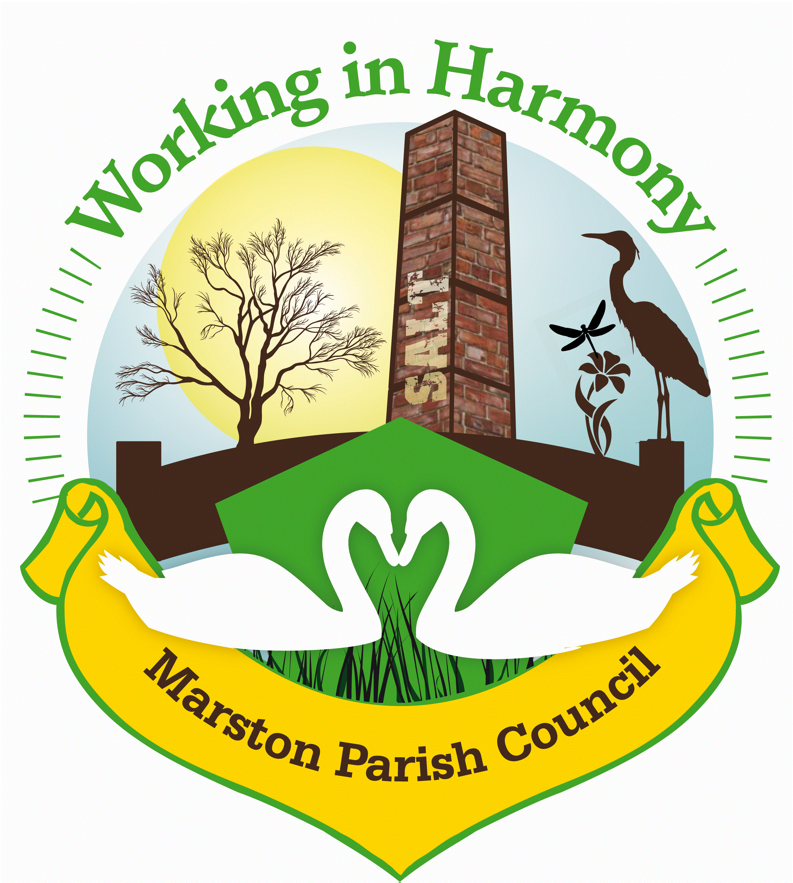 Marston Parish Council Advertising Policy
Adopted: February 2020
Review: February 2021

1.0 Objective
To promote guidelines on the type and nature of advertisements which appear in MPC publications, noticeboards and display screens. This policy outlines the approach that Marston Parish Council will take in accepting advertising that will be inserted into our newsletter; Marston Murmurs, Noticeboards or on our website.

2.0 Definition
Advertising is defined as an agreement between MPC and the advertiser to display information to promote the sale of commercial products, services or amenities for an agreed fee. This is in addition to MPC publications, noticeboards and display screens, which promote charitable, voluntary, non-profit making organisations, clubs and bodies.

3.0 The Parish Council reserves the right to refuse advertising for any reason without explanation.

4.0 Any advertising on our website will be:
- Honest
- Responsible
- Fair
- In line with our Mission Statement

5.0 The Parish Council will aim to publish adverts in accordance with the UK Code of Non-Broadcast Advertising, Sales Promotion and Direct Marketing and the British Code of Advertising Standards.

6.0 Acceptable adverts:
- Will not promote support for any political party
- Will not contain material that can be judged inappropriate and likely to cause offence or likely to subject the Parish Council to prosecution
- Will not reflect or appear to support any form of discrimination
- Will not be accepted from organisations that are currently in unresolved financial, legal or other proceedings with Marston Parish or Cheshire West and Chester Councils. Due consideration will also include organisations that may have similar issues nationally. The Parish Council will seek to maintain its objectivity and to not contribute to influencing the outcome of such ongoing matters.
- Will reflect the opinions and feelings of the residents. Through its monitoring and continual discourse with its parishioners, the Parish Council will ensure that advertising is compatible with the needs and will of the community.
- Will promote the aims of the Council’s Mission Statement, the Local plan and contribute positively to the well-being of the environment and local community.

7.0 Agreeing to place an advert does not imply the Parish Council’s endorsement or recommendation of any commercial product or service.

8.0 All advertisements will be for a minimum of 3 editions with full payment up front.

Signature:  ………………………………………………………………….. | Date:  ………………………………
Position:
…………………………………………………………………..
Signature:  ………………………………………………………………….. | Date:  ………………………………
Position:
…………………………………………………………………..

