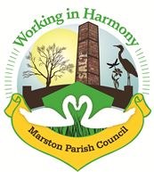 | Marston Murmurs
The Newsletter of Your Marston Parish Council November 2020

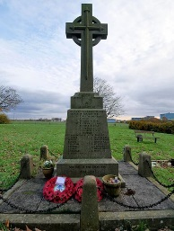
Marston Cenotaph & The Marston Lads
It's Sunday 28th June 1914 and the weather is warm. Many have attended Saint Paul's Church and are now making their way back to spend the rest of the day with family and friends.

Reading the newspaper after Sunday lunch, people chat about the issues of the day. Still, just local news is of interest, national and international news was for the Government and businesses to worry about.

It's a tough life, but they don't know any different. Most men in the area work for the local salt mine, often with a company house. The average number of rooms for a house, which included the kitchen, was four, and with an average household of eight people, things were pretty cramped.

On this same Sunday, and hundreds of miles away in Serbia, events were unfolding which the Marston community were oblivious too. That day would be the start of a struggle that would cost the lives of 28 Marston Lads and devastate the village. Over the next four years every single house in the area would be either directly or indirectly affected.
Life from this point would never be the same again.
On that same day, 28th June 1914, the Austrian Archduke Franz Ferdinand and his wife, together with their driver, were all assassinated by Bosnian revolutionary, Gavrilo Princip.
This single act was not solely responsible for the outbreak of the First World War; but it was the catalyst and the trigger that would set in motion a conflict which would lead to approximately 20 million deaths and over 22 million wounded, leaving local communities grieving as they lost a whole generation.

Six years later, on the 13th November 1920, the crowds gathered around a new monument, the Marston Memorial. Funded by local business as well as the community; and for many who had lost sons, husbands, brothers, fathers
and friends, it was their sole point of remembrance. For those fortunate
enough to have been identified, they lie in a foreign land including France, Belgium, Germany, Egypt and Iraq, one sailor remains within his ship, sunk by a German u-boat in 1915.

A simple name on the Marston Memorial is all families have left of their loved ones. On the 13th November 1920, the day is an emotional one and we remember that day now, 100 years later.

Marston War Memorial was erected in the churchyard south-west of the former Church of St Paul, now the site of Marston Church Hall, as a permanent testament to the sacrifice made by local servicemen who lost their lives. It was paid for by public donations. The memorial, dedicated to 27 Marston men, was carved by A & A Senior Monumental Masons of Victoria Road, Northwich and unveiled by Mr G W Malcolm. The ceremony included the Bishop of Chester, and local clergy and dignitaries.

Two First World War soldier's war graves also stand in the same churchyard. Following the Second World War the memorial was re-dedicated with the addition of ten names of fallen servicemen.

It was restored in 1998, due to subsidence as a result of historic salt mining at the Salt Lion Work,s where many of the fallen had worked.

Lest we forget …

John Poole (84 Ollershaw Lane) • Arthur Henry Bannister (Wincham Lane) Clarence Musgrave (51 Ollershaw Lane) • Thomas Cooke (9 George Lane) George Cowley (8 Ollershaw Lane) • Henry Jacks (66 Ollershaw Lane) • Thomas Walker (17 Ollershaw Lane) • James Venables (address unknown) • Thomas Hicks (5 Cross Street) • George Edgar Austin (47 Ollershaw Lane) • Walter Poole (Alliance Salt Works) •Samuel Pearson (27 Ollershaw Lane) • John Johnson (45 Wincham Lane) • William Hesketh (Cranage Mill) • Samuel Riley (27 Marston Lane) • Fredrick Perrin (14 Cross Street) • William Rowe (Gibsons Fold)
Thomas Barton (11 Marston Lane) • James Poole (Alliance Salt Works) • Stanley Mathews (24/26 Ollershaw Lane) • James Edwin Riley (49 Ollershaw Lane) Thomas Bramall (43 Chapel Street) • James Spencer (80 Chapel Street) • John Hollas Mathews (26 Ollershaw Lane) • Wlliam Neild (11 Cross Street) • Joseph Robinson (Marston Common Farm) • Leonard White (1 Wincham Lane) Herbert Sharpes (10 Ollershaw Lane)

Parish News

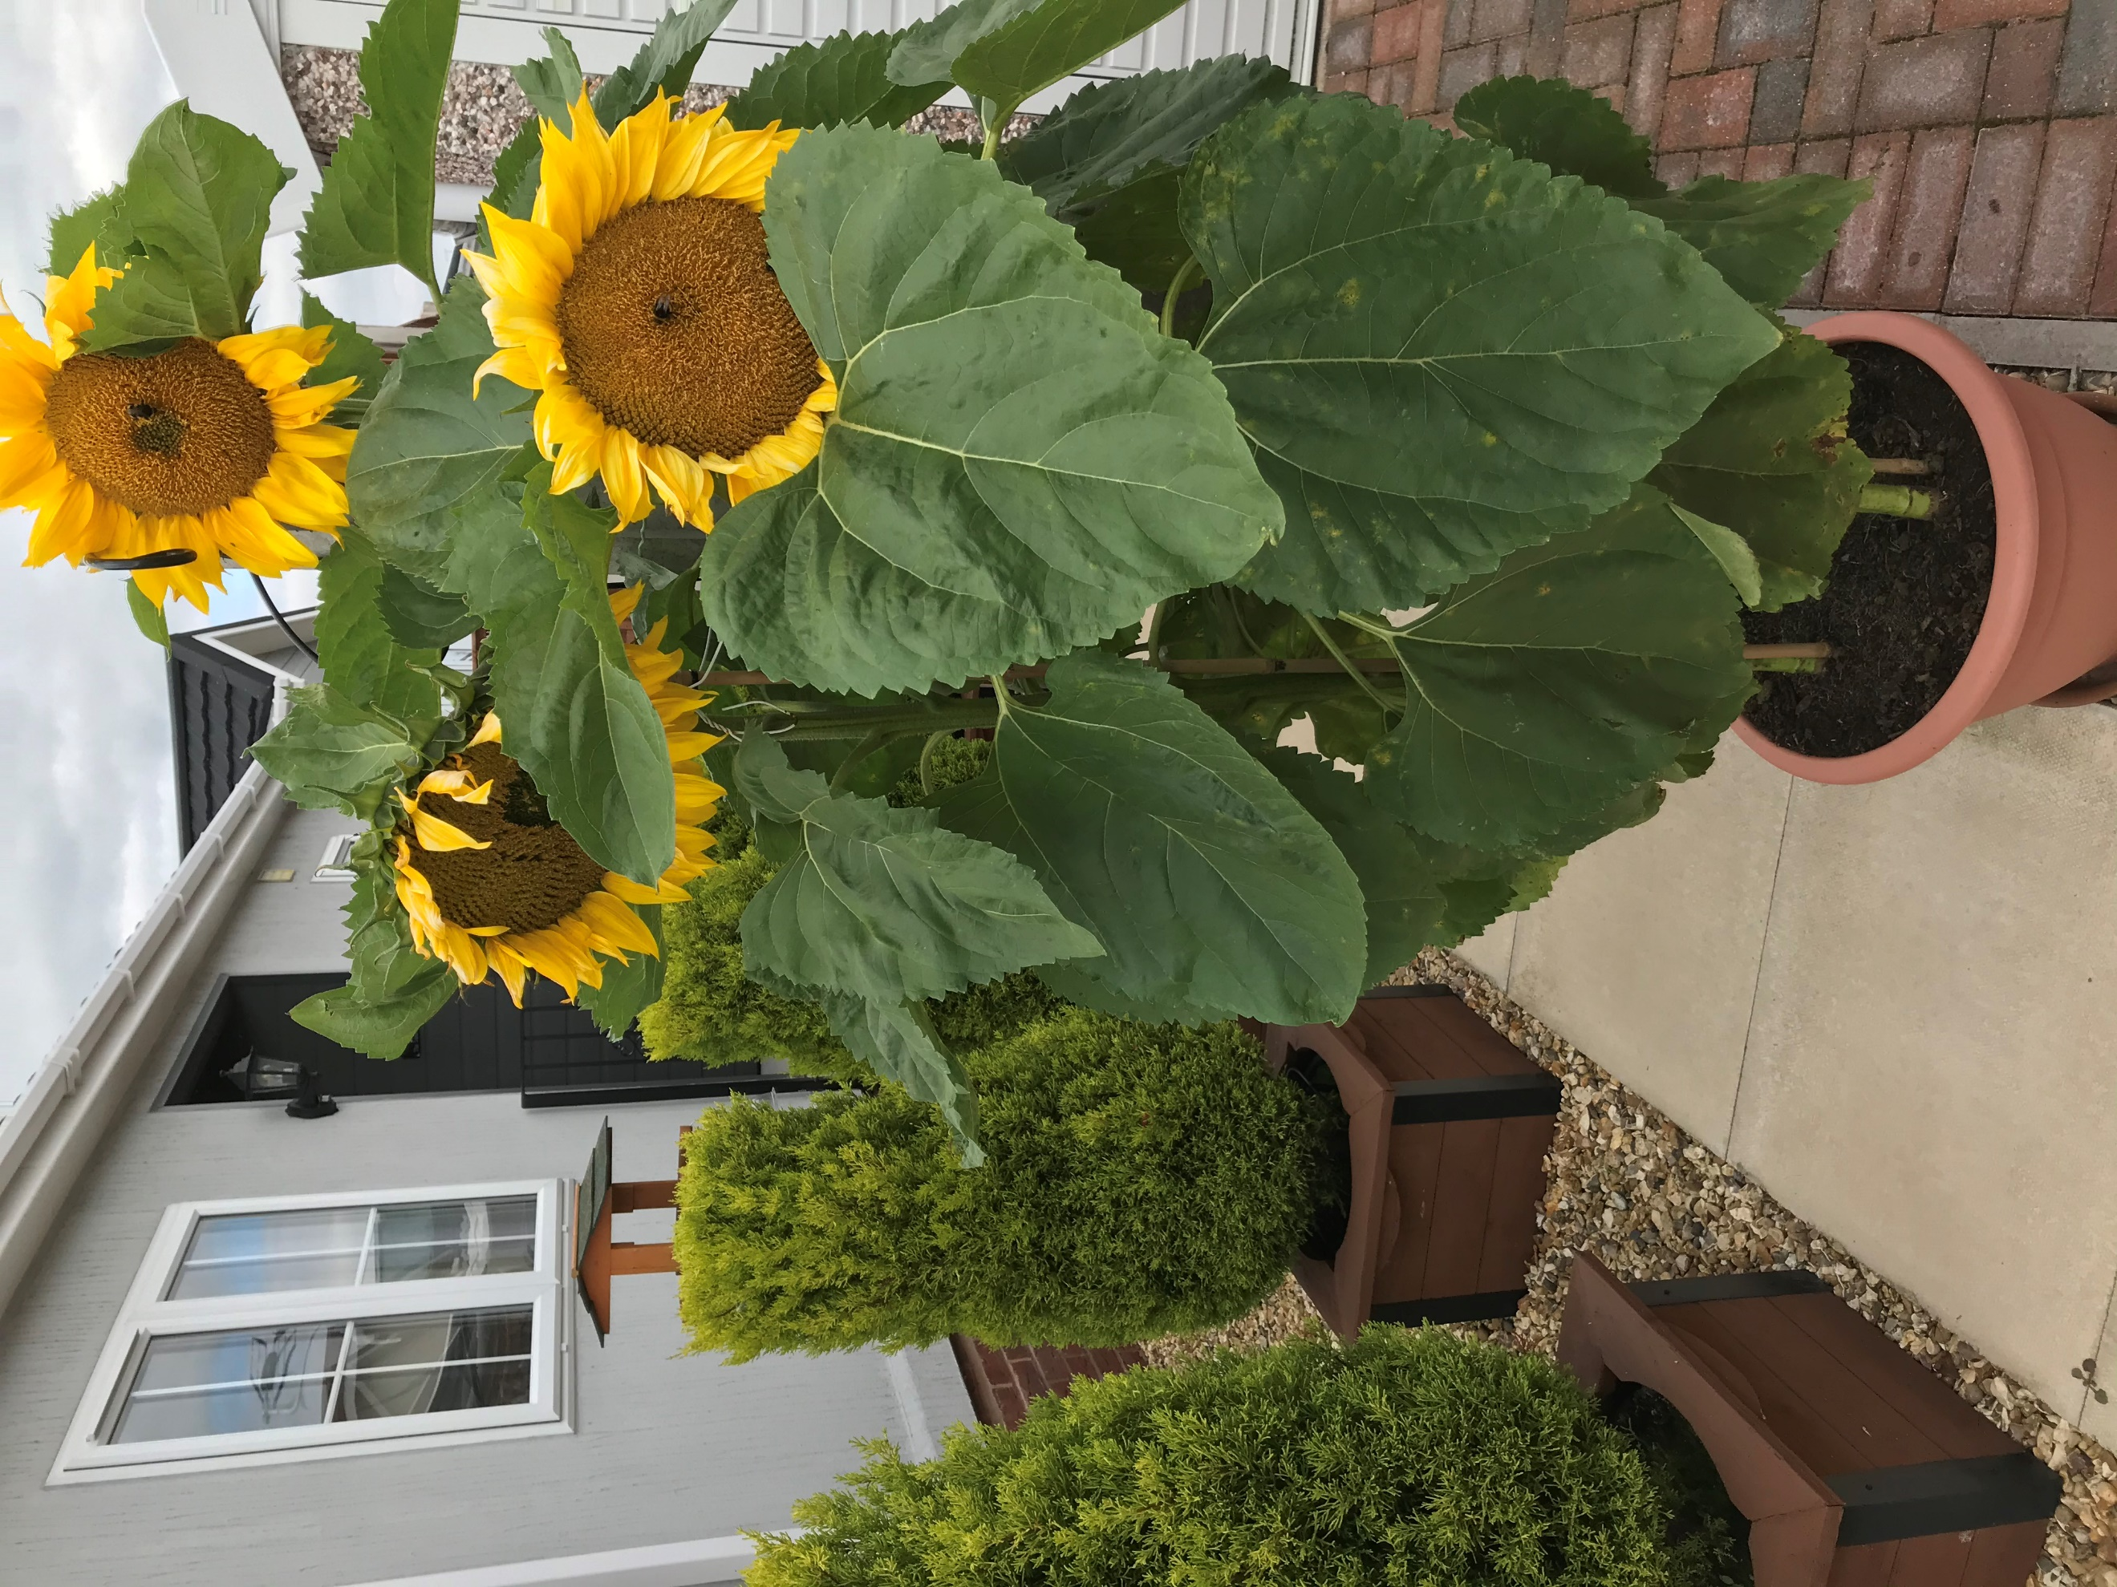
Ashwood Park resident Ted Kelly sent us this photo of sunflowers that he grew after receiving the seeds through his letterbox. He would like to thank the kind soul who delivered the seeds, it was heart warming to receive such a gift. We believe seeds were posted through many resident’s letter boxes during the early COVID-19 lockdown.

Thank you to all those involved it certainly brightens up your day!

Thanks also go out to Andrew Drinkwater of iQ SEO in Chester. He has kindly donated 50 outside white candles for our Remembrance Day and Cenotaph Centenary commemorations.

Unfortunately, the Mobile Library has been cancelled until further notice

Bits ‘n’ Bobs

November
As well as Armistice Day the 11th November is also St. Martins Day. Weather this day was seen as an indicator of the season to come, commemorated in several old wives’ tale and rhymes.
‘Wind North West at Martinmas severe winter to come’
‘If the leaves of the trees and grapevines do not fall before Matin’s day, a cold winter may be expected’
‘Ice before Martinmas, enough to bear a duck, the rest of winter is sure to be muck’

Bonfire Toffee
Bonfire toffee is the absolute treat on Bonfire Night, the 5th of November. No Bonfire Night would be complete without it! The toffee is also known as Plot Toffee, understandably because of Guy Fawkes and his plot to blow up the houses of parliament.
This Treacle Toffee recipe for Bonfire Toffee is simple, quick, and easy to make but must be approached with caution; toffee gets very, very hot as it is boiled reaching temperatures as high as 160°C
It is important that the toffee reaches the correct temperature or it will not be brittle and hard when it sets. It is worth investing in a sugar thermometer. That said, the toffee still tastes good even when a little soft and sticky, but it won't be real Bonfire Toffee. Treacle toffee keeps very well stored in an airtight tin so make enough for Bonfire Night and extra for Christmas.

Ingredients

450g | Unrefined Dark Muscovado Sugar
125ml | Water
75g | Unsalted Butter
100ml | Golden Syrup
120ml | Black Treacle
1tbsp | White Wine Vinegar

Method
- Butter 15cm square tin and line with greaseproof paper.
- Put all the ingredients into a heavy based saucepan and heat slowly, stirring until the butter melts and the sugar dissolves then increase the heat to bring the mixture to the boil.
- If using a sugar thermometer boil to 160°C. Or test by dropping a small amount into a glass of cold water. It is ready when a blob of toffee is slightly stretchy but breaks with pressure.
- Pour into the tin leave to set. To help break into even sized pieces mark the toffee when it is partially set. Break the toffee into pieces when completely cool.

Summary Minutes of Marston Parish
Council Meeting of 21st October 2020

We have now had a quote for the repair of the cenotaph, permission has been granted by the Diocese we just await word from the local conservation officer. Any donation to help towards this cost would be greatly appreciated. Please contact the clerk at clerk@marstonparishcouncil.co.uk

Planning Applications:
- Planning Application 20/03395/FUL – 114 Ollershaw Lane – Single storey extension linking to outbuilding – this is linking the house to an outbuilding that was granted permission on 17/00726/FUL application in 2017 which included the erection of the outbuilding. A condition was set that the outbuilding was only to be used for its original purpose and not ancillary accommodation. The joining of the two buildings it seems would break this condition. Clerk to send comments on these grounds
- Appeal to Enforcement on application 18/04924/AGR – change of use of land. The PC objected to the original application (which was refused) and the CW&C then issued the enforcement based upon a perceived change of use from agricultural to storage of commercial/domestic vehicles and waste. The appellant has appealed the enforcement not the application. Clerk to send PC comments supporting the enforcement
- Planning Application 20/03661/CAT – Lion Salt Works – Tree leaning over neighbouring property – no objections

POP Quiz – The 1960’s
- Who was the drummer with the Dave Clark Five?
- Which small Mod group were all under five foot, six tall?
- Who completed the line up of Dave Dee, Dozy, Beaky and Mick?
- In 1965 The Kinks sang about Dedicated Follower of what?
- What did Marvin Gaye Hear it Through in 1969?
- What did the Beatles Want to Hold on their first US No 1?
- What Corner had Andy Fairweather-Low as lead singer?
- Which little girl sang “The Locomotion” in 1962?
- Which head of the Diddymen shed Tears in 1965?
- What is Over according to the Seekers in 1965?
- Which Engelbert Humperdinck song’s second line is “Let me go”?
- Which 60’s Dance was popularized by Chubby Checker?
- Which country were the Bachelors from?
- What sort of Vibrations did the Beach Boys have in 1966?
- Which Moody Blues member later joined Wings?
- What follows “Ob-La-Di” in the Marmalade No,1?
- Which lover of Romeo was a hit for the Four Pennies?
- In 1960 what was the profession of Lonnie Donegan’s dad?
- Which pretty pink bird was a No.1 for Manfred Mann?
- How old was the Sweet person Neil Sedaka wished Happy Birthday to in 1961?
- Who came between Peter and Mary in the trio?
- With what song did Sandie Shaw win the 1967 Eurovision song contest?
- Where should you where a flower if going to San Francisco?
- Why did Jimi Hendrix play his Fender Stratocaster upside down?
- Which Des sang about Careless Hands in 1967?
- Who had a hit in 1960 with “Itsy Bitsy Teenie Weenie Yellow Polka Dot Bikini?
- Which 1967 chart his became the signature song of Aretha Franklin?
- Which fictional characters had a chart hit in 1969 with “Sugar Sugar”?
- Which Beatles chart hit was created by Paul McCartney as “song for Ringo”?
- Who sang lead vocals on “Baby Love”?

Parish Events

Remembrance Sunday & Cenotaph Centenary

Remembrance Sunday this year is on Sunday 8th November and the centenary of the Cenotaph in the church yard is 13th November. To help us commemorate Remembrance Day and the Centenary of the Cenotaph we are planning the following:

Sun 1st November – 2-3pm Please bring any Evergreen cuttings, poppies and items for display that you have to the hall
Sat 7th November - 2-4pm Exhibition of war memorabilia, photos, information on the arch, memorial and soldiers, competition entries (there will be a one way system with hand gel sanitation, we also ask that you bring your own mask)
Sun 8th November - 10.45am Remembrance service in Church Yard, hall open for exhibition walk through

Anyone with WWI or WWII photo’s and/or memorabilia (especially local information) who would be willing to share them with the community please bring along on 1st Novemebr. We will be able to photocopy them and then use them for an exhibition and display on the Evergreen Arch.

Anyone with evergreen cuttings (firs, ivy etc..) please bring them along on the 1st as well.

Answers to POP Quiz
1. Dave Clark. 2. Small Faces. 3. Tich. 4. Fashion, 5. The Grapevine. 6. Your hand. 7. Amen. 8. Eva. 9. Ken Dodd. 10. The Carnival. 11. Release Me. 12. The Twist. 13. Ireland. 14. Good. 15. Denny Laine. 16.Ob-La-Da. 17. Juliet. 18. Dustman. 19. Flamingo. 20. 16. 21. Paul. 22. Puppet on a String. 23. Your Hair. 24. He was left handed. 25. O’Connor. 26. Brian Hyland. 27. Respect. 28. The Archies. 29. Yellow Submarine. 30. Diana Ross.
Useful Contacts

CWAC Councillors
Lynn Gibbon 07581 226814
lyn.Gibbon@cheshirewestandchester.gov.uk
Norman Wright 01606 74788
norman.wright@chesterwestandchester.gov.uk
Phil Marshall 07917 171438
phil.marshall@cheshirewestandchester.gov.uk

Cheshire West and Chester Council
Mon-Fri 81m-7pm and Sat 91m-12.30pm
Online at www.cheshirewestandchester.gov.uk
General enquiries 0300 1238123
Highways 0300 1237036
Street Scene 0300 1237026

PCSO Diana Wiggins PCSO20322 diana.wiggins@cheshire.pnn.police.uk
Officer Terry Boyle PC4555 terry.boyle@cheshire.pnn.police.uk
Dial 101 in a non-emergency and 999 in an emergency

Ester McVey – your local MP Telephone: 01625 529922

Marston Parish Council cannot be held responsible for any errors, misprints or opinions stated in this publication. The views expressed by the contributors are their own and not necessarily the views of the editor .
Your Contributions and ideas are welcomed!
We are always grateful for ideas and articles from any of our readers . Just send them through to the editor or any one of the councillors or even give us a ring.

Further information on Parish matters can be found on marstonparishcouncil.co.uk
Back copies of the Marston Murmurs newsletters are also on this website.
For Facebook users see: Facebook/Marstonparishcouncil. also Facebook/All about Marston and surrounding areas
Copies of this newsletter can be obtained from The Salt Barge, The Lion Salt Works or the Church Hall. Those who wish an electronic copy email info@marstonparishcouncil.co.uk.

PCSO November Surgery dates:
7th Barnton Library 1-2pm, Wincham Community centre 3-4 pm
12th Barnton Library 10-11 am, Wincham Community centre 11.30- 12.30 pm
16th Barnton Library 2-3pm, Wincham Community centre 3.30- 4.30pm
22nd Barnton Library 1-2pm, Wincham Community centre 2.30-3.30pm
27th Barnton Library 2-3pm, Wincham Community centre 3.30-4.30pm
Citizens Advice Cheshire West
For help with debt, benefits, housing, family and work problems you can contact us at:
www.advicebyemail.org.uk
Adviceline 0344 5766111
COVID-19
Two new COVID-19 local testing sites will open in west Cheshire this week, allowing residents with COVID-19 symptoms to book a test. The sites in Winsford and Northwich will be open from 8am to 8pm, seven-days-a-week. They are walk-through sites and no parking is available at either location. The Winsford site, Queensway Testing Centre, is located on Queensway and has begun offering tests. It can only be accessed by the pathway that leads to the rear of Wyvern House. The Northwich site, The Old Depot Testing Centre, opens on 10 October and is located on Leicester Street on an area of unused land that was a former Cheshire County Council depot. To book a test visit the NHS website or call 119
Your Marston Parish Councillors

 |  |  | Chair: Marion Potts  07842 894733  marion.potts703@btinternet.com |  | Iain Stead  07737 185215  iainstead2@gmail.com
 |  |  | Chris Anthwal  07775 573089  chris.anthwal@talk21.com |  | Phil Carter  07879 843900  philandshe@hotmail.co.uk
 |  |  | Warren Davies  07879 458195  warrenjdavies59@  gmail.com |  | Dave Collier  07901 810558  davecollier87@hotmail.co.uk
 |  | Clerk: Caroline Constable  clerk@marstonparishcouncil.co.uk |  |  | Amanda Nixon  07786 135375  hoasisgarden@gmail.com,
Website: www.marstonparishcouncil.co.uk
Email us at: info@marstonparishcouncil.co.uk
Facebook: www.facebook.com/marstonparish

Remembrance Day Colouring Competition
Colour in and return to the letter box at the Church Hall before 6th November. Winners will receive a small gift and your picture will form part of our remembrance commemorations

Name………………………………………………………………………………………………

Age…………………………………………………………………………………………………

Contact…………………………………………………………………………………………...

Williams Printers advert

