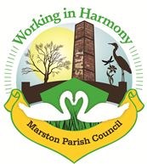 | Marston  Murmurs
The Newsletter of Your Marston Parish Council September 2020

We would like to apologise for not having a newsletter these last few months; obviously due to the pandemic, we hope to get back to a full edition of Marston Murmurs asap, until then, here is some news about what has been happening in the village and what is planned in the near future.

A number of councillors and some residents formed a working group at the start of the COVID-19 pandemic and have been helping many members of our community during these difficult times with shopping and the collection of medicines etc.. Thanks go out to all those involved. Anyone still requiring help please don’t hesitate to get in touch.
Reopening of the Church Hall - We are putting government guidelines in place to ensure the safe opening of the hall. It is our priority to ensure the safety of Marston residents and all users of the hall and we must ensure all measures are in place before going forward safely.

Marston Murmurs September 2020

Coffee Mornings; we hope to resume these sometime
in September and we will also be hosting our yearly Macmillan Coffee Morning, dates to be arranged.

The hall will be a lot warmer this winter as we have had a new central heating system fitted. Thanks to all the local businesses and tradesmen for all your help and support with installation.
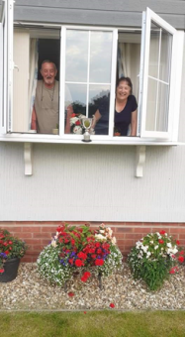
We recently held our front garden competition, which was won by Dave and Margaret Hodkinson from Juniper Close, Ashwood Park. Their border of marigolds, lobelia, baskets and pots were a riot of colour set off by their neat lawn and weed free garden; it certainly catches your eye. Well done! As always, it was a difficult decision as there are so many worthy gardens to see.

It is interesting to see the changes and development of many gardens over the past few months. The use of space, accessories and plant varieties has been impressive. Well done to all our village gardeners.
It has been brought to our attention that there has been some fly tipping on the children’s play area in Higher Marston and

the addition of compostable material left in a resident’s skip!
If you are aware of any fly tipping please report this via the Cheshire West and Cheshire website at https://www.cheshirewestandchester.gov.uk/residents/contact-us/report-it/report-it.aspx or by calling 0300 123 8123.
We would also like to thank the litter pickers who have been doing a great job keeping the village tidy. There has been an unusual amount of litter this year due to lockdown bringing increased visitor numbers to the local area.

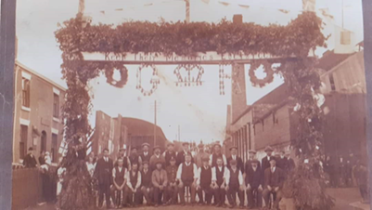
As you may remember we are celebrating the centenary of the Cenotaph in our churchyard. We are basing our celebration on a traditional commemoration which started after the First World War and was then adopted all over the North West of England. There is a picture hanging in the church hall of an early commemoration of the lives lost in WW1 which shows a large archway, spanning the road outside the Lion Salt Works. This photograph has been a mystery for many years. The writing on the arch is partially covered, but we have found out it reads “Keep their memories evergreen”. We are hoping to recreate this on a smaller scale in the churchyard for Remembrance Sunday on the 8th November.

 |  |  | Chair: Marion Potts  07842 894733  marion.potts703@gmail.com |  |  | Iain Stead  07737 185215  iainstead2@gmail.com
 |  |  | Chris Anthwal  07775 573089  chris.anthwal@talk21.com |  |  | Phil Carter  07879 843900  philandshe@hotmail.co.uk
 |  |  | Warren Davies  07879 458195  warrenjdavies59@  gmail.com |  |  | Dave Collier  07901 810558  davecollier87@hotmail.co.uk
 |  | Clerk: Caroline Constable  clerk@marstonparishcouncil.co.uk |  |  |  | Amanda Nixon  07786 135375  hoasisgarden@gmail.com
Website: www.marstonparishcouncil.co.uk
Email us at: info@marstonparishcouncil.co.uk
Facebook: www.facebook.com/marstonparishcouncil

