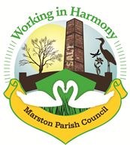 | Marston Murmurs
The Newsletter of Your Marston Parish Council November 21

This year we will be erecting the Evergreen Arch in the Church yard on Saturday 6th November to be in place for Remembrance Day on the 11th and Remembrance Sunday on the 14th.

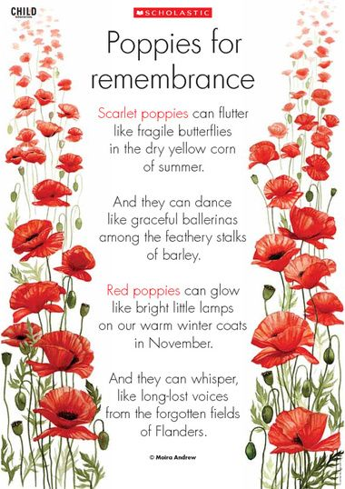
For those of you who don’t know; the Evergreen Arch was created last year in honour of the Centenary of the Cenotaph and is in memoriam to those who lost their lives in the First World and Second World Wars.

If you would like to help or can provide cuttings of evergreens for decoration of the Evergreen Arch, please join us from 10am on the 6th.

We will be conducting our Remembrance Sunday service on the 14th at 10.55am. Please arrive for 10.45am.

We will be serving teas, coffee and biscuits in the Church Hall following the service.

Marston, surprisingly, has eight buildings that are recorded in the National Heritage List for England as designated listed buildings. The listed buildings consist of a mile post on the canal, a farmhouse and associated buildings, the War Memorial (Cenotaph) and four buildings associated with the Lion Salt Works, which is also a scheduled monument.

For a small village we seem to have a fair share of heritage buildings and structures. Walkers along the canal towpath will pass the milepost just before the bend approaching Marbury Park.
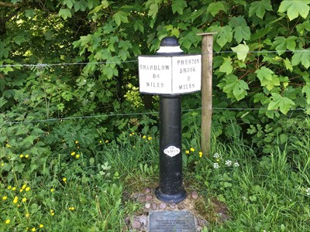
The Trent and Mersey Canal
The Trent and Mersey Canal was the UK's first long distance canal and as the name suggests was built to give a connection to the Rivers Trent and Mersey (access to the Mersey was actually via the Bridgewater Canal with some locks at Runcorn that no longer exist). It opened in 1777 and is 93.5 miles (150.5 km) long and stretches from its connection with the Bridgewater Canal at Preston Brook to its connection with the River Trent at Derwent Mouth.
The mileposts all have a standard design and give the distance to Preston Brook and Shardlow which is just short of Derwent Mouth.
The Trent & Mersey Canal Society was founded in 1974 to campaign for the re-opening of Harecastle Tunnel. The society were also involved in the campaign to make Shardlow a conservation area. Both campaigns were successful. In 1977 the society celebrated the bicentenary of the canal with a large rally/event, and also launched a campaign to restore all the mileposts on the canal. Original mileposts removed during the war were found, cleaned and painted before being reinstalled. Thirty-four new mileposts were cast and the final one was unveiled in October 1985.
This is one of the replacement mileposts and there is a plaque in the ground at its base.

NEW MILEPOST WAS SPONSORED BY
COUNCILLOR M FLETCHER
MARSTON PARISH COUNCIL
& OTHER VOLUNTARY CONTRIBUTIONS
REPLACED BY THE
TRENT & MERSEY CANAL SOCIETY
AND UNVEILED BY
COUNCILLOR M FLETCHER
ON SUNDAY 6th NOVEMBER 1980
PLAQUE BUTLER JONES OF BOGNOR REGIS
The milepost is an Historic England Grade II Listed Building and is listed as follows:
"Canal milestone, 1814, of cast iron. Circular post carrying plate curved in plan inscribed SHARDLOW 84 MILES: PRESTON BROOK 8 MILES in raised Roman capitals. Restored 1977. T&MCS 1977 inscribed on raised quatrefoil on the post”.

Does anyone remember the Milepost being replaced? We hope when the fingerpost at the triangle is returned beautifully restored, to surround the base with stone flags and posts (or something at least) to prevent damage to the post. The Parish Council are seeking the relevant permission to do this from CWAC.
Parish News

Next Parish Council Meeting
Our next meeting is scheduled for Wednesday 10th November 2021 at 7pm in the Church Hall.

A full risk assessment will be conducted beforehand ensuring that current government guidelines are followed, and we ask that any member of the public wishing to attend contact our clerk at clerk@marstonparishcouncil.co.uk for information.

The Macmillan Coffee Morning was held on Tuesday 28th September, and we enjoyed meeting with old friends and new, doing competitions and a having a quiz. We had generous donations towards the raffle and made a record £290.00.
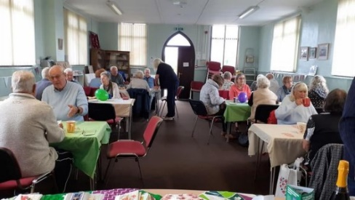
Thanks to all who supported the event and made it such a success and a very enjoyable morning. Special thanks to Millie from Marston Lane who generously donated handmade cards to sell, they were beautifully made and very popular.

Heritage Fingerpost, latest news
As many of you are aware, the fingerpost on the triangle (junction of Marston Lane & Ollershaw Lane) has been taken away for restoration. Unfortunately, the man who is doing the work for us has contracted Covid-19 and had to isolate. We understand he is OK but clearly it has slowed down progress. He has however sent an update on the work done so far.

“I have all the bits separated successfully and the post is being grit blasted along with the sound components. The finger with the broken collar ‘MARSTON’ is with the man who welds aluminium for me and I am hoping that this can be successfully repaired. It’s not always the case with old aluminium components, so my fingers are crossed. If it proves unsuccessful then I will have to cast a whole new component.

The pattern is being prepared for the (previously missing) LOSTOCK GRALAM, NORTHWICH finger – i.e. the letters are being applied to each side of the pattern to get it ready for mould making and then casting. I will await the outcome of the weld repair before putting this item into the foundry as I may have to have two fingers cast.

So it’s all going to plan although moving slowly as a result of COVID I’m afraid.”

The grass on the triangle has finally been cut and we plan to plant the area with daffodils shortly so the area will look a “picture” come the springtime with bright spring flowers and our restored fingerpost.

Neighbourhood Plan
Wincham have decided to pull out of the joint Neighbourhood Plan due to the resignation of some councillors and they now feel that they cannot commit to the work. Marston councillors and our clerk agreed that it was an important task and that we should continue without them. A new Marston Neighbourhood Plan will need to be created and we will need the help of residents to get the job done.
So, we ask for residents to get involved. Once fully organised we will aim to meet once a month to move the project forward and ask for your help.
We don’t need anyone with any formal training just a willingness to get involved and help formulate a vision for what and how you see our village developing over the next few years.
If you are interested then please get in touch via info@marstonparishcouncil.co.uk

Summary Minutes of Marston Parish
Council Meeting of 13th October 2021

Complaints have been received from numerous residents on Higher Marston regarding the planting of trees/shrubs in the area surrounding the play area and along some of the grass verges on the estate. CW&C have been notified and we are awaiting a response.

Our application for an Interactive Traffic Sign at the bend at the bottom of Ollershaw Lane has now been approved. We are awaiting a meeting with highways to discuss it’s design and siting. Thanks go to our Ward Councillors Norman Wright, Lynn Gibbon and Phil Marshall who awarded us £3000 towards the cost.
Wincham PC have pulled out of our joint Neighbourhood Plan and it was agreed that we would continue without them. A notice in MM would be placed asking residents to get involved.

Planning Application 21/03791/FUL – erection of detached dwelling next to 4 Cross Street – submission of change to dwelling style – clerk advised that changes to style included 2 storey to 3 storey with master bedroom now in roof space with roof velux windows and slight changes to front of property – all agreed that further comments would be futile as planning already consented and changes would not impact current residents

Quiz

- What was opened in 1931 by George Mottershead and his family at Upton by Chester?
- Where in Cheshire would you find the UK's largest rock salt mine?
- Charles Lutwidge Dodgson was born on January 27, 1832, in Daresbury, Cheshire - by what pen name is he better known?
- Which town, designated a new town in 1968, is the largest in Cheshire?
- What did the Romans name the town on the site of modern Chester?
- Which town derives its name from the King of England who ruled from 1016 to 1035?
- There are three Cheshire towns ending in "wich", can you name them?
- Their historic nickname was "The Chemics" after the main industry in Widnes, but what is the modern nickname of Widness rugby league team?
- Which local food is first mentioned by Thomas Muffet in his nutrition book Health's Improvement published circa 1580?
- Who was the Member of Parliament for Tatton from 2001 to 2017?
- The walled city of Chester is on which river?
- Which village at the base of a steep and thickly wooded sandstone escarpment is known for its affluence and expensive houses?
- Name the singer, songwriter, record producer, actor, and television personality born on 20 January 1971 in Frodsham, Cheshire?
- Which town has the county's largest collections of historic buildings, second only to Chester?
- In which decade was Crewe railway station first built?
- Which motorway, also known as the North Cheshire motorway, runs for 33-miles from Junction 4 of the M60 to Dunkirk, near Chester?

Bits ‘n’ Bobs

Gardening Jobs
- Feed the birds – there is still plenty of natural food in the hedgerows and gardens, but start feeding now so they know where to come in leaner times. Choose high-fat food to help them through the winter; peanuts, grated cheese and suet balls
- Plant up a pot or a hanging basket with winter bedding; pack violas and pansies close as they won’t grow much
- Buy little terracotta pot feet to raise your pots a couple of centimetres off the ground and stop them getting waterlogged over winter
- Plant tulip bulbs – at three times their own depth, in pots or directly into the garden
PumpKin Soup Recipe

Ingredients
- 1 large onion, chopped
- 2 carrots, peeled and chopped
- 2 garlic cloves
- 1 bay leaf
- 25g/1oz unsalted butter
- 2 tbsp olive oil
- 1 medium pumpkin (prepared weight about 850g/1lb 14oz) deseeded and roughly chopped
- 1 medium-sized floury potato, such as Maris Piper, roughly chopped
- 1 litre/1¾ pint vegetable or chicken stock, a little extra may be needed
- 100ml/3½fl oz double cream
- 3 tbsp pumpkin seeds
- salt and freshly ground black pepper

Method
- Put the onion, carrots, garlic bay leaf, butter and half the olive oil into a large pan. Cook over a low–medium heat for about 10 minutes until the vegetables are tender but not coloured.
- Add the squash and potato, mix to combine and cook for a further 2–3 minutes. Pour in the stock, season well and bring to the boil. Reduce the heat to a gentle simmer, half cover the pan with a lid and continue to cook for about 40 minutes until the squash is really tender when tested with the point of a knife.
- Pick out the bay leaf and blend the soup until smooth using a stick blender.
- Add the cream and a little more stock if the soup is on the thick side, taste for seasoning, adding more salt and pepper as required.
- Meanwhile, heat the remaining oil in a frying pan over a medium heat and add the pumpkin seeds and fry quickly until the seeds start to pop. Remove from the pan.
- Ladle the soup into bowls and serve with a swirl of cream and the toasted pumpkin seeds.

ANSWERS to Quiz
1.Chester Zoo, 2. Winsford, 3. Lewis Carrol, 4. Warrington, 5. Deva, 6. Knutsford (Cunetesford ("Canute's ford") after King Canute), 7. Northwich, Middlewich and Nantwich, 8. The Vikings, 9. Cheshire cheese, 10. George Osborne, 11. River Dee,
12. Alderley Edge, 13. Gary Barlow, 14. Nantwich, 15. 1830s (1837), 16. M56

Parish Events

Remembrance Sunday
Our service will take place at 10.55am on Sunday 14th November.
Please arrive by 10.45am.
We will again have the Evergreen Arch erected and will be placing lit candles in remembrance of all those local men who lost their lives in the First and Second World Wars.
Refreshments will be served afterwards in the Church Hall.

Response to the Coronavirus Pandemic

COVID-19 Outbreak Board meetings are still being held regularly to monitor the current situation. The general public can listen in and ask questions (once registered). Go to: http://cmttpublic.cheshirewestandchester.gov.uk/mgCommitteeDetails.aspx?ID=1107 to register or look at meeting minutes/agendas and statistics.

- If you are in need of help
You should ask:
- Family. Do you have family close at hand?
- A friendly neighbour?
- Marston Parish Community Support team
  - Our contacts are below
- Contact the CW&C Helpline on 0300 1237031 or www.cheshirewestandchester.gov.uk/covid

Some residents have problems with the supply of prescriptions or provisions when their regular supporters may be unavailable. In this case don’t hesitate to use the support of your Marston Parish Community Support team.

For those struggling financially
The lockdown has faced many with financial difficulties. Those who may be struggling to pay bills please use the CW&C Helpline as above.

- If You’re Struggling to Afford Food
You may be able to get food bank vouchers but you will need a referral which you can obtain from:
- CW&C Help Scheme 0300 123 7065 9am – 5pm
- Citizens Advice Bureau: CAB Helpline – 0344 576 6111 or call Sean on 07894 238 963, from 9.30am to 4.30pm - weekdays.
- WCCAB – Gaynor – 07736 621235 or Sam – 07596 338067, Monday – Thursday 9am – 5pm, weekdays only.

- Other problems?
Our volunteer team is here to help please don’t hesitate to give us a ring and we’ll be pleased to assist.
Useful Contacts

CWAC Councillors
Lynn Gibbon 07581 226814
lynn.gibbon@cheshirewestandchester.gov.uk
Norman Wright 01606 74788
norman.wright@cheshirewestandchester.gov.uk
Phil Marshall 07917 171438
phil.marshall@cheshirewestandchester.gov.uk

Cheshire West and Chester Council
Mon-Fri 81m-7pm and Sat 91m-12.30pm
Online at www.cheshirewestandchester.gov.uk
General enquiries 0300 1238123
Highways 0300 1237036
Street Scene 0300 1237026

PCSO Diana Wiggins PCSO20322 diana.wiggins@cheshire.pnn.police.uk
Officer Terry Boyle PC4555 terry.boyle@cheshire.pnn.police.uk
Dial 101 in a non-emergency and 999 in an emergency

Ester McVey – your local MP Telephone: 01625 529922

Marston Parish Council cannot be held responsible for any errors, misprints or opinions stated in this publication. The views expressed by the contributors are their own and not necessarily the views of the parish council.
Your Contributions and ideas are welcomed!
We are always grateful for ideas and articles from any of our readers . Just send them through to the clerk or any one of the councillors

Further information on Parish matters can be found on marstonparishcouncil.co.uk
Back copies of the Marston Murmurs newsletters are also on this website.
For Facebook see: Facebook/marstonparishcouncil
Those who wish an electronic copy email info@marstonparishcouncil.co.uk.

Your Marston Parish Councillors

 |  | Chair: Marion Potts  07842 894733  marion.potts703@gmail.com |  | Ian Stanley  ian@ianstanley.org.uk
 |  | Julie Ledger |  | Phil Carter  07879 843900  philandshe@hotmail.co.uk
 |  | Angela Johnson  angelazjohnson48@gmail.com |  | Dave Collier  07901 810558  davecollier87@hotmail.co.uk
 | Clerk: Caroline Constable  clerk@marstonparishcouncil.co.uk |  |  | Amanda Nixon  07786 135375  hoasisgarden@gmail.com,
Website: www.marstonparishcouncil.co.uk
Email us at: info@marstonparishcouncil.co.uk
Facebook: www.facebook.com/marstonparish

Space for Williams advert

