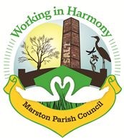 | Marston Murmurs
The Newsletter of Your Marston Parish Council June 21

We are entering the 6th month of the year and approaching the longest day. With the lockdown restrictions decreasing and vaccinations giving some immunity, we are looking forward to taking steps towards life as it was before the Corona virus pandemic. The Parish Council have begun face to face meetings again (socially distanced) and are making plans to resume some Parish Council activities this month, although initially they may be different to how we had previously run them. We look forward to welcoming back old friends and neighbours and extend a warm welcome to anyone who would like to join us.
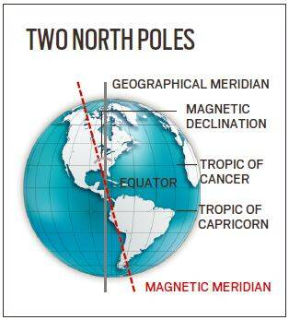
On 1st June 1831, James Clarke Ross, Commander in the British Navy and experienced Artic explorer, discovered the magnetic North Pole. This is different to the geographic North Pole and sits hundreds of miles south beyond the Canadian Artic.
The 10th of June marks the anniversary of the first emergency usage of the Morse Code distress code signal ‘SOS’. Marked by three dots, three dashes, then three dots, it can be transmitted by flashes of light or radio ‘beeps’. The signal was first used when the Cunard liner RMS Slavonia was wreaked off the Azores. Two steamers in the area heard the distress call and went to her rescue. All on board survived.
Parish News

Reopening of Church Hall
Following the easing of lockdown measures we are happy to report that we will be re-opening the Church Hall from June 2021 onwards.
Coffee mornings will recommence from the 8th June (10am – 12 noon). Numbers will however have to be limited to 25 (including the rule of six) to enable us to maintain social distancing and ensure everyone is kept safe. A risk assessment will be carried out before every coffee morning and hand sanitiser will be provided at the entrance and exit. Our parish councillors will be providing table service (aren’t you the lucky ones) and only they will be allowed use of the kitchen. Toilets will be available with a circular route through the building to avoid people crossing in close quarters. We look forward to welcoming you back.

The hall will also be available for hire with a new set of Terms and Conditions to ensure that the hall is kept clean and virus free.
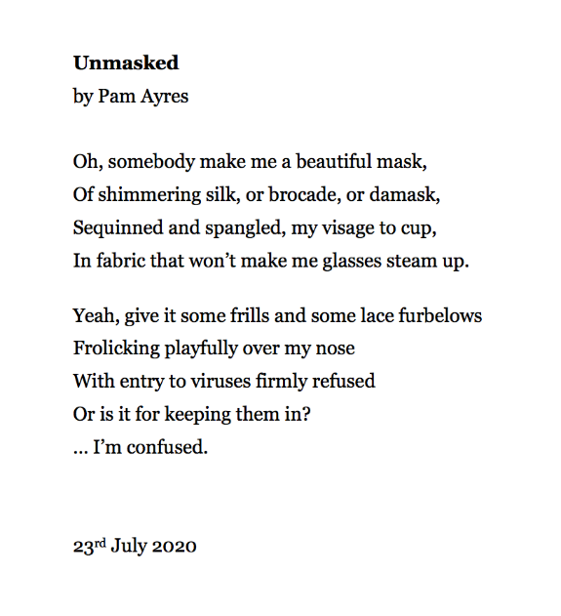
Please remember your mask is still required indoors and will be required at the hall until seated.

Parish Councillor Vacancy
We have received an application to fill our last parish council vacancy. We will hopefully be co-opting the candidate at our June parish council meeting.

Next Parish Council Meeting
Our next meeting is scheduled for Wednesday 9th June 2021 at 7pm in the Church Hall.

A full risk assessment will be conducted beforehand ensuring that current government guidelines are followed and we ask that any member of the public wishing to attend contact our clerk at clerk@marstonparishcouncil.co.uk for information.

Heritage Fingerpost - Update
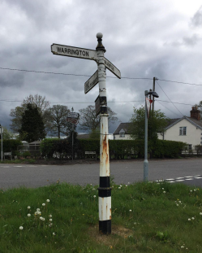
We may take it for granted but our fingerpost has been helping travellers at its current location on the A559 crossroads since at least 1887. It is marked on an Ordnance Survey map of that date and of course could be even older. The base of the post is cast iron and likely to be original. However, the top is aluminium so is probably mid-twentieth century.
The post is in urgent need of repair.
The parish council intends to restore the post to the condition as it was in its hey-day. If you’ve never given it a second thought do go and take a look at it but please don’t lean on it! We have noticed that although sited on a crossroads there are only three fingers remaining, so clearly one finger is missing. It has probably been missing for some time but must have been there originally.
The parish council plans to reinstate that finger at the same time. Looking just down the road at the junction with Earles Lane we can extrapolate from the fingerpost there that our missing sign should point down the A559 towards “Lostock Gralam” and “Northwich”.
If anyone has an old photograph to confirm this please let us know. Indeed, if anyone has any old photograph of the fingerpost in times past and would like to share this with the village then do contact us.

Marston Walking Group
We have had numerous requests to restart the walking group but with the loss of Warren Davies as coordinator we are now in need of someone to take the mantle.
If you are interested in creating walks for fellow residents of around 3 miles and perhaps taking in other local sites of historical or botanical interest (even if it means driving to them) then please get in touch via info@marstonparishcouncil.co.uk.

Summary Minutes of Marston Parish
Council Meeting of 12th May 2021

Tarmacking Church Hall Car Park - We have accepted a quote to have part of the Church Hall Car Park tarmacked to provide us with a better surface that will be easier to traverse. Work will hopefully commence at the beginning of June.
Reopening of Church Hall – after agreeing to open the hall we are in the process of drawing up new Terms and Conditions of hire and use and will be creating risk assessments to ensure that all users are kept safe.
Planning Applications – Ward Councillor Norman Wright asked whether we were aware of the planning application 20/0368/FUL for 103 homes off New Warrington Road. We were not. Clerk is to investigate and report back before any further action.
It had also been noticed that a planning application for the demolition of the building at the entrance to Ashwood Park, off Chapel Street, Wincham had been submitted. Clerk to investigate and report back before any further action.
20/03395/FUL – 114 Ollershaw Lane – Approval. Clerk had contacted planning about what appeared to be the breaking of conditions set on original planning application for the building of an ‘office’ in the garden of the property. CW&C advised that it was deemed that connecting the main house with the building did not constitute ancillary accommodation and thus was not breaking the condition thus the approval.
Inquiry into land behind Ollershaw Lane – inquiry has now taken place, we are awaiting the result.
Lamppost Poppies – clerk ordered the 20 poppies as per last month’s meeting and they have been received. The poppies will be placed along Ollershaw Lane and Marston Lane later in the year.
Parish Councillor Vacancy – we have received an application for the vacancy and if no other application is received before next month’s meeting the candidate will be co-opted.

Bits ‘n’ Bobs

Gardening Jobs

The longest day of the year falls on June 20th, bringing warmer temperatures and extra sunlight.
Flowers are blossoming, there’s lots to harvest in the vegetable garden, and keeping on top of bolting plants is a priority — particularly weeds!
Check plants daily and water them if the soil is dry — especially newly planted fruit trees and shrubs that are still getting established.
Harden off any remaining half-hardy bedding plants ready for planting out.
Use blinds or apply shade paint to prevent your greenhouse from overheating. Remember to open vents and doors on warm days.
Keep on top of weeding. Your plants shouldn’t have to compete for precious water, light, and nutrients.
19th – 27th June is National Picnic week. A lovely way to meet friends and relations in the open air and we are lucky to have many beautiful areas to sit and enjoy the views and your meal.
Just please remember to take your rubbish home with you or dispose of it in a nearby bin.

Gardening Knowledge Quiz

- The love apple is the original name for what?
2. How can you tell the age of a tree?
3. Which plant takes its name from the Italian phrase for beautiful women?
4. Which grain is used to make semolina?
5. Which television presenter and gardener owns a garden in Herefordshire called Longmeadow?
6. Which garden in the Cotswolds is notable for its miles of sculptured hedges?
7. Which plant, widespread in Britain, if touched causes a serious chemical reaction which makes skin hypersensitive to ultraviolet light?
8. Which kings lived at Kew Palace at Kew Gardens?
9. Which garden plant in the 17th century was exchanged as a form of currency?
10. What is the art of cutting shrubs into ornamental shapes called?
11. Often called England's greatest gardener, what is Capability Brown's given first name?
12. Soil can be acidic, alkaline or what?
13. The spice, saffron, comes from which flower?
14. Where is the biggest tree in the world, giant sequoia, found?
15, What fruit hit, or more likely fell, near Isaac Newton and helped him develop the law of gravity?
16. I am a woody stemmed plant, usually branched near the base and lacking a single trunk....what am I?
17. On which continent did broccoli originate?
18. What herb beginning with ‘A’ has soothing properties?
19. Roughly, how many varieties of avocado are there? 5, 50, 500 or 5,000?
20. What vitamin is most prevalent in a lime?
21. True or false? Chelsea is Britain’s largest flower show.
22. What type of goldfish are often found in decorative garden ponds?
23. How many fountain-type statuaries are there in the Versailles gardens? 4, 40, or 11?
24. For how long can seeds remain dormant? Months, a few days, years or one season?
25. How long does it take to produce asparagus the first time you plant it?
26. What is the definition of a deciduous tree?
27. In what season should you plant daffodil bulbs?
28. Which of these is NOT a winter crop? Cabbage, leek, parsnip or tomato?

Response to the Coronavirus Pandemic

COVID-19 Outbreak Board meetings are still being held regularly to monitor the current situation. The general public can listen in and ask questions (once registered). Go to: http://cmttpublic.cheshirewestandchester.gov.uk/mgCommitteeDetails.aspx?ID=1107 to register or look at meeting minutes/agendas and statistics.

Book of Reflection

The book of reflection is still available to be read or added to.

Go to:
https://www.theonlinebookcompany.com/OnlineBooks/CheshireWestandChesterCouncil/Content/Filler

Anyone without internet access who wishes to add a message can telephone: 01244 972214 or 01244 977074 Monday to Friday 9am to 5pm.

- If you are in need of help
You should ask:
- Family. Do you have family close at hand?
- A friendly neighbour?
- Marston Parish Community Support team
  - Our contacts are below
- Contact the CW&C Helpline on 0300 1237031 or www.cheshirewestandchester.gov.uk/covid

Some residents have problems with the supply of prescriptions or provisions when their regular supporters may be unavailable. In this case don’t hesitate to use the support of your Marston Parish Community Support team.

For those struggling financially
The lockdown has faced many with financial difficulties. Those who may be struggling to pay bills please use the CW&C Helpline as above.

- If You’re Struggling to Afford Food
You may be able to get food bank vouchers but you will need a referral which you can obtain from:
- CW&C Help Scheme 0300 123 7065 9am – 5pm
- Citizens Advice Bureau: CAB Helpline – 0344 576 6111 or call Sean on 07894 238 963, from 9.30am to 4.30pm - weekdays.
- WCCAB – Gaynor – 07736 621235 or Sam – 07596 338067, Monday – Thursday 9am – 5pm, weekdays only.

Once you have your referral Mid Cheshire Foodbank provides food parcels from its distribution centres in Northwich and Winsford by appointment. Deliveries can be arranged for residents in Northwich and Winsford who are unable to leave their home.
We are conscious that many will not have access to the internet so please feel free to ring in confidence one of our Councillors, who will put you in touch with the right person in Cheshire West and Chester Council.

- Other problems?
Our volunteer team is here to help please don’t hesitate to give us a ring and we’ll be pleased to assist.

If you wish to volunteer to provide support in our community please contact us.

Phil Carter 07879 843900 philandshe@hotmail.co.uk
Dave Featherstone 01606 631702
Marion Potts 07842 894733 marion.potts703@gmail.com

Parish Events
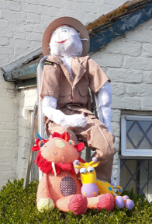
Lockdown Scarecrow competition
Congratulations to Emma and Elizabeth from Marston Lane on winning the recent Scarecrow competition with their 'We missed the zoo' entry. Sadly, the weather limited the time the animals ventured outside but the zoo-keeper scarecrow was impressive. We have been informed they have big plans for next year’s competition, so thinking caps on and lets’ have lots of Scarecrows next year
Keep Britain Tidy – Litter Pick
We have signed up for this year’s Keep Britain Tidy campaign and intend on doing a litter pick on Sunday 6th June 2021. Any volunteers wishing to help please get in touch with our Chairperson Marion Potts (details at the back of Murmurs)

Best Kept Garden
We will be running our Best Kept Garden later in the summer so let’s all start thinking about our front gardens and let’s make this a year of abundant displays and a village to be proud of

Answers to Quiz:
1.Tomato 2. Number of rings 3. Belladonna 4. Wheat 5. Monty Don
6. Hidcote 7. Giant hogweed 8. George II and George III 9. Tulips in the Netherlands 10.Topiary 11. Lancelot 12. Neutral 13. Crocus 14. California, USA 15. Apple 16. Shrub 17. Europe 18. Aloe vera 19. 500 20. Vitamin C 21.False RHS Hampton Court Palace Garden Festival is bigger 22.Koi 23. 11 24. Years 25. Two to three years 26. These are trees like oaks that shed their leaves every autumn 27. In the fall. More specifically, September to November. 28. Tomato
Adverts
Useful Contacts

CWAC Councillors
Lynn Gibbon 07581 226814
lynn.gibbon@cheshirewestandchester.gov.uk
Norman Wright 01606 74788
norman.wright@cheshirewestandchester.gov.uk
Phil Marshall 07917 171438
phil.marshall@cheshirewestandchester.gov.uk

Cheshire West and Chester Council
Mon-Fri 81m-7pm and Sat 91m-12.30pm
Online at www.cheshirewestandchester.gov.uk
General enquiries 0300 1238123
Highways 0300 1237036
Street Scene 0300 1237026

PCSO Diana Wiggins PCSO20322 diana.wiggins@cheshire.pnn.police.uk
Officer Terry Boyle PC4555 terry.boyle@cheshire.pnn.police.uk
Dial 101 in a non-emergency and 999 in an emergency

Ester McVey – your local MP Telephone: 01625 529922

Marston Parish Council cannot be held responsible for any errors, misprints or opinions stated in this publication. The views expressed by the contributors are their own and not necessarily the views of the parish council.
Your Contributions and ideas are welcomed!
We are always grateful for ideas and articles from any of our readers . Just send them through to the clerk or any one of the councillors

Further information on Parish matters can be found on marstonparishcouncil.co.uk
Back copies of the Marston Murmurs newsletters are also on this website.
For Facebook see: Facebook/marstonparishcouncil
Those who wish an electronic copy email info@marstonparishcouncil.co.uk.

Your Marston Parish Councillors

 |  | Chair: Marion Potts  07842 894733  marion.potts703@gmail.com |  | Ian Stanley  ian@ianstanley.org.uk
? |  | Could this be you? |  | Phil Carter  07879 843900  philandshe@hotmail.co.uk
 |  | Angela Johnson  angelazjohnson48@gmail.com |  | Dave Collier  07901 810558  davecollier87@hotmail.co.uk
 | Clerk: Caroline Constable  clerk@marstonparishcouncil.co.uk |  |  | Amanda Nixon  07786 135375  hoasisgarden@gmail.com,
Website: www.marstonparishcouncil.co.uk
Email us at: info@marstonparishcouncil.co.uk
Facebook: www.facebook.com/marstonparish

Space for Williams advert

