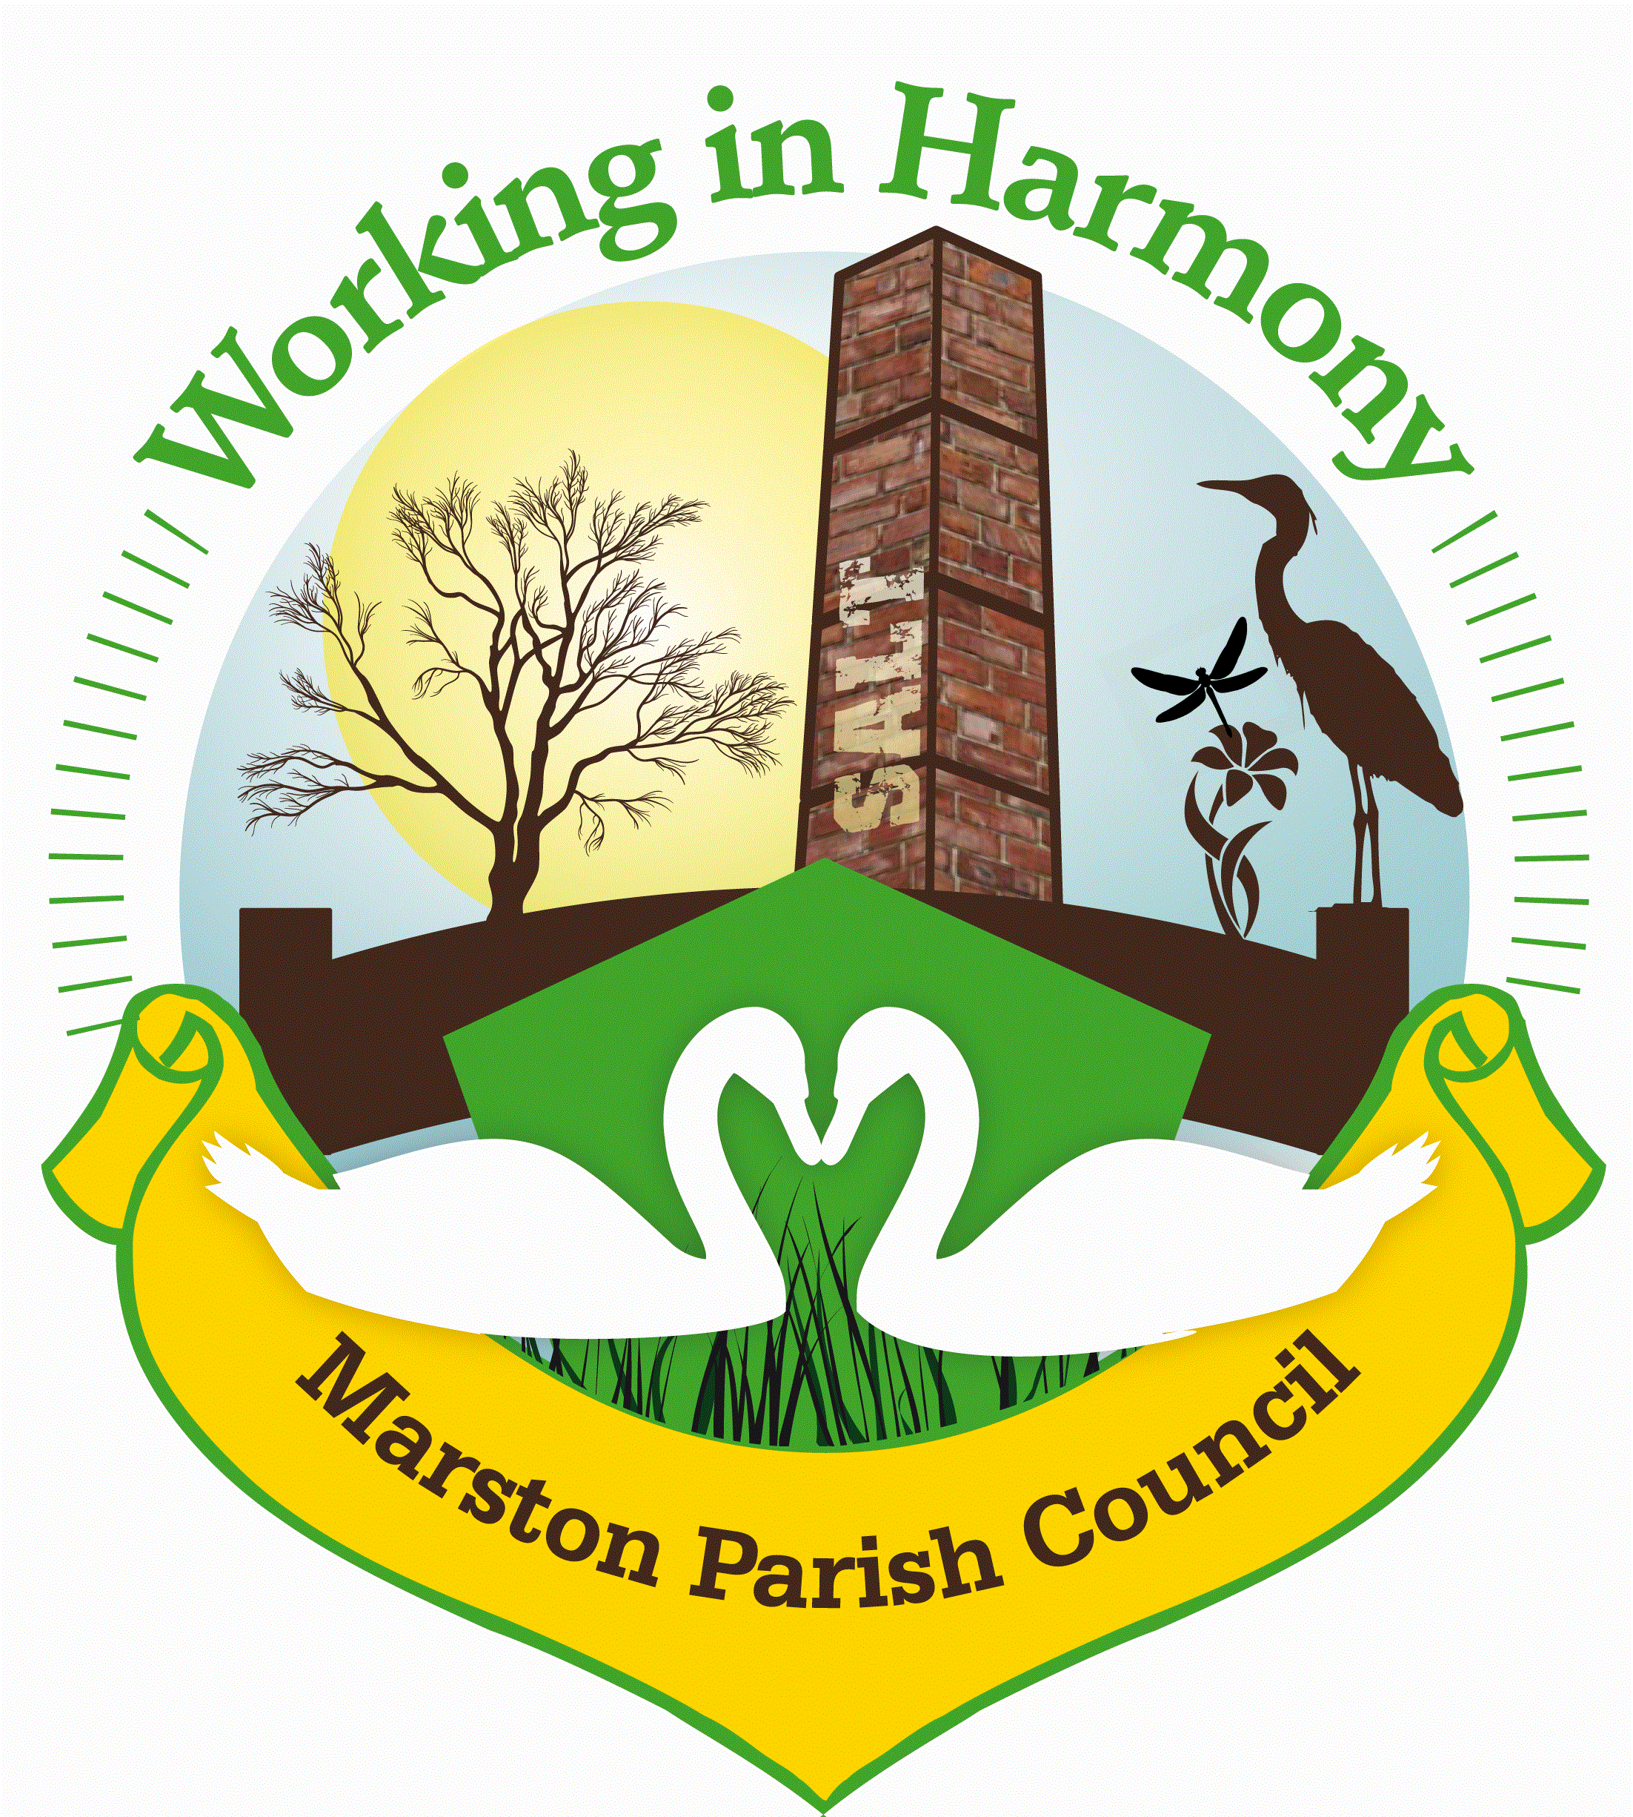
Marston Parish Council
Neighbourhood Plan Meeting – 12th June 2023
Minutes

Attendees: Caroline Constable (PC), Ian Stanley (PC), Angela Johnson (PC), Paul Gallagher (R) James & Anne Wilson (R’s)
Venue: The Salt Barge
The items on the agenda were listed and a quick explanation given:
Bigger Picture:
Stages
Producing a Constitution
- the name of the neighbourhood plan (already done)
- the purpose of the neighbourhood plan (this needs to include ‘promoting or improving the social, economic and environmental well-being of an area that consists of or includes the neighbourhood area concerned’)
- working arrangements, including sub-groups, partners and their roles
- pattern of meetings and details of how decisions will be made
- details of governance, including official positions (such as chair, secretary, treasurer)
- arrangements for operation and financial management (funding)
- details of how declared interests and potential conflicts of interest will be recorded and managed
- membership joining procedures for new members
- duration of the plan (5 years from being approved, as set out in legislation)
Building evidence base
- Residents
- Businesses
Community Engagement
- How
- When
Create Draft Plan
Pre-Submission Consultation
Independent Examination
Referendum
Future
- Monitoring
- Updating
Today’s Tasks
- Create Constitution
- Allocate initial roles
- Assign tasks
  - Looking for Funding/help
  - Research into Local Plan
  - Research into other NP’s with similar demographic

The Neighbourhood Plan (NP) has been designated as ‘Marston Neighbourhood Plan’ and corresponds to the parish boundary.
Discussions:
Purpose: The purpose and goals of the NP were discussed with primary points as follows:
- Preservation of village feel and aesthetic
- Preservation of fingerpost(s)
- Preservation of the ACV – Community Asset – The Salt Barge Pub
- Look at whether there are any other community assets that need to be protected from development/loss – Garage/shop
- Stop any development of the greenbelt
- Stop any further industrialisation of the village
- Maintain Church Hall/Church Yard
- Maintain environment – flashes, ponds etc..
- Maintenance of footpaths
- Maintenance of verges/hedgerows
- Maintain number of properties within the village – no significant increases to maintain village feel
- Limit building/land change of use
- Control traffic
Constitution:
Decision Making/Governance/Policies & Procedures:
How decisions would be made/changed with regards to what to include in NP were discussed. It was agreed that a consensus would be needed to take objectives/decisions forward. If those decisions then needed to be reviewed a further vote would be needed. Tasks would be assigned at each meeting. These would then be reported at the next meeting.
A declaration of interests from members was also discussed (as in line with council procedures and rules) to avoid any members of the group directing decisions biasedly. It was decided that A Declaration of interests will be added to each meeting agenda.
Scheduling of meetings was also discussed and it was decided that multiple meetings would not be scheduled in advance. It was decided that at the end of each meeting the next date would be agreed based upon what tasks would be needed.
The duration and venue of meetings was also discussed and it was decided that if numbers increased dramatically meetings would be moved from The Salt Barge to the Church Hall.
It was agreed that initially Caroline would run and minute the meetings but if numbers grow this would be reviewed.
New membership was also discussed. It was agreed that residents could join the group whenever interest was shown.
Close:
The meeting closed with the assigning of tasks. Caroline stated that members of the group needed to be assigned to different tasks so that the plan could move along as quickly as possible. She stated that the following was needed before the next meeting:
What areas of the Local Plan do we think we should be concerned with?
What funding is available?
Look at other villlage’s NP’s whose demographic is similar to Marston’s.
These tasks were assigned as follows:
Caroline and Angela were to look into the local plan
Ian and Paul were to look into funding
Anne and James were to look at other NP’s.

It was agreed that the next meeting would be held after the summer and a date of 7/9/23, was set, 6.30pm at The Salt Barge (Ian would put a reminder in Marston Murmurs)

Abbreviations: PC – Parish Council, R – Resident, NP – Neighbourhood Plan

