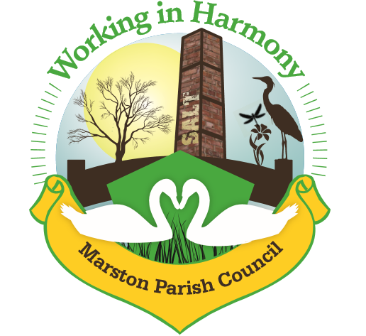
Minutes of Marston Parish Council meeting held on 15th July 2020
This meeting was held virtually using Google Meet
All councillors were sent an invitation email at 6.30pm with a link to ‘Join’ the meeting. Clerk ran the meeting and accepted all join requests
There were a number of technical issues delaying the start of the meeting and as such Cllr’s Philip Carter (Phc) & dave Collier (DC) and Ward Cllr Phil Marshall (PM) were unable to attend
The meeting opened at 19:20
Present:
Parish Cllrs; Chairman M Potts (MP), Amanda Nixon (AN), Warren Davies (WD), Chris Anthwal (CA)
Ward Cllrs;
Clerk; Caroline Constable (CC)
Apologies:
Apologies received from Cllr Iain Stead (IS)
Declarations of interest:
There were no declarations of interest
Dispensations:
There were no dispensations
Public Forum:
There were no requests from the public to join the meeting

Minutes:
The minutes from the parish council meeting of 15/06/2020 were agreed and approved.

Actions from previous meeting:
Due to the nature of the meeting actions from previous meeting will be held off until next official face to face meeting

 | Agenda Point | Assigned to..
1 | Parish Cllr Reports  Cllr CA – Opening of Church Hall – it was decided after a discussion regarding the government guidelines for opening community buildings during the COVID-19 crisis that it was not feasible to open at this time. The hall is regularly used by bands and choirs and current legislation does not allow for singing in enclosed public places and due to the requirement for sanitization after use it was deemed impossible to manage and so the hall will remain closed to the general public for the foreseeable future.  Food deliveries to the vulnerable – Cllr CA organises the delivery of food to a number or vulnerable residents and requires assistance as she will be away next week. Cllr PhC has volunteered to take over the next delivery and others may need to help at some point. Clerk to liaise with cllr’s to ensure deliveries continue. Cllr CA to send information to clerk. | PhC  CC  CA
2 | Ward Cllr Reports  Ward Cllr PM – Ward Cllr PM was unable to join the meeting due to technical issues but sent the following via email:  The layby bins requested have been declined as after inspection, the location does not meet the 'Criteria'. I have responded today asking for clarification on the criteria, so I can challenge the decision.  Clerk responded stating that the area was regularly cleaned by clrr’s and residents which is why there was no litter when it was inspected.  Local Bus Route request - this has been passed into our representatives on the Local Transport Review. I'll keep you posted, they may need some more information / input from residents.  I've also had a request for some sort of bike racks / fixed points to secure bikes at the entry points to the flashes. If we are encouraging the locality to get out, walk and cycle - seems a sensible request. I've spoken to the Active Transport lead who has referred it to localities. Again I'll keep you posted.  Clerk requested that a bike rake be erected at the Church Hall, there had been one there previously but it had gone missing in recent times.
3 | Progress Reports  - Cenotaph Repair – Clerk and Cllr MP advised that the two companies who had quoted in the past have failed to respond or responded with a quote that was too expensive (£5000) and so a further 2 quotes are needed. Photographs have been sent to the vicar for sending to the bishop to gain authority for the repairs.  Cllr AN aware of a member of the Royal British Legion (RBL)who have contacts for masons but due to their self isolating during this time they are unavailable. Clerk advised that any repair can only be carried out by an Imperial War Museum (IWM) approved contractor, clerk to contact RBL and IWM to find list of approved contractors. | CC
4 | Finance  - Signing of 2019-2020 AGAR accounting documents and External Audit Exemption Certificate – Cllr MP signed  - Signing off of latest accounts – to 30/06/20 - Cllr MP checked and signed bank reconciliations  Invoices received & cheques created:  - Clerks Purchases and Expenses - £139.97  Including: keys @ £18.60 & printer ink subscription @ £7.99 & printer paper @ £6.98  Clerks Salary 31.25 hours @ £15ph - £468.75  Total payable £608.72 Chq no. 1243  - Scottish Power £214.28 taken 26/6/20  - MH Electrical – work on lights & alarm at hall £157.50 chq no. 1244  - Howard Worth – internal audit £300 chq no. 1245  Rent received (via Cllr CA):  No rent  Cleaner  5 weeks 15/6 – 12/7 £50  Invoices received from Bookings agent  5 weeks 15/6 – 12/7 £50  £100 chq to Cllr CA chq no. 1246
5 | Correspondence  - Cheshire Community Action – membership renewal – it was agreed to renew the membership. Chq 1247 £20 created by Cllr MP  - Cheshire Community Action – Community Buildings membership – it was agreed that this membership might be useful and if we do not feel that it has benefited the pc by the end of the year we will not renew next year. Chq 1248 £50 created by Cllr MP  - Historic England - 1471157 Marston War Memorial, Marston: Invitation to comment on Consultation Report for addition as historic interest & emails from Tony Hayes and Cllr Potts. Cllr MP had given Tony Hayes the go ahead to send comments as he has the most information regarding the Cenotaph. It was mentioned by Cllr CA that the fact that the Church Hall was also built by Marston residents and that this should be included in any comments. Clerk to email Tony Hayes asking him whether this information can be included | CC
6 | WCAG Compliance  The deadline for WCAG compliance is 23/9/20. Clerk and Cllr PhC attended a virtual conference hosted by itseeze consultants highlighting guidelines and how pc’s need to update their websites. It was clear from this that MPC website is not compliant in a number of ways. Clerk performed a test of the MPC website and highlighted a number of issues; including keyboard accessibility and use of mobiles and tablets, issues which she is unqualified to address. Clerk also advised that web developers charge approximately £1300 per day and it is estimated that a simple website would take between 1 and 3 days to make compliant. Itseeze can provide an upgrade of a website for £450+vat plus a monthly subscription of approximately £50 a month ensuring that the website is always compliant. All cllr’s agreed that the website needs to be updated and improved and gave the go ahead for clerk to contact the local consultants.  Clerk advised that a ward members grant could be applied for to cover the initial £450+vat cost otherwise the initial and ongoing costs could be easily managed due to the £10000 small businesses grant received in May. Clerk to apply | CC  CC
7 | Any other business  Cllr WD – MPC comments on Tour and Store appeal have been produced by cllr WD. Clerk advised that the only missing element was the inaccuracies in the Transport Plan provided by Tour and Store. Cllr IS had agreed to look at this but has been unavailable for comment. Clerk provided an initial analysis of the report and this will be added to Cllr WD’s report and submitted to CW&C.  Cllr AN – keys still needed for the hall. Clerk to organise | CC  CC

Confirmed date of next meeting, due to COVID-19 situation no meeting planned

Meeting closed at 20:13

Abbreviations: pc (parish council), cllr (councilor), cllrs’ (councillors’), cllr’s (councillor’s), CW&C (Cheshire West and Chester), MM (Marston Murmurs), MPC (Marston Parish Council)

