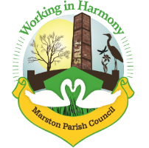

Marston Parish Council meeting 15th July 2020
Agenda
Note: This meeting will be held as a virtual meeting due to the current COVID-19 situation using Google Meet.
Attendees: any member of the public wishing to ‘attend’ should email the clerk at clerk@marstonparishcouncil.co.uk for instructions on how to join the meeting..
Apologies for Absence: To receive apologies and approve reasons for absence
Declarations of interest: Register of interests - Councillors are reminded of the need to update their register of interests and the need to disclose both the type of interest and its nature
Dispensations: To consider requests for Dispensations
Public Forum: Electors and members of the public are welcome to raise their issues or present matters of interest to the council
Minutes: To consider the approval of the minutes of the last meeting of the Council

- Parish Councillors’ reports and items for future agendas
Each Councillor is requested to use this opportunity to report minor matters of information not included elsewhere on the agenda
- Ward Councillor Reports
For information only, items raised for discussion will appear on the agenda for the next meeting
- Progress Reports
  - Cenotaph
- Finance
  - Signing of AGAR documents including Exemption Certificate for 19/20
  - Accounts sign off April-June
  - To consider payments to be made as per attached list
- Correspondence
To note correspondence received as per attached list
- WCAG compliance
To consider the state of PC website and its non-compliance with current legislation and look at using a third party to ensure continued compliance
- Any other business
To note any other business arisen during discussions

Date of the next meeting. Due to current COVID-19 issues next meeting not scheduled

