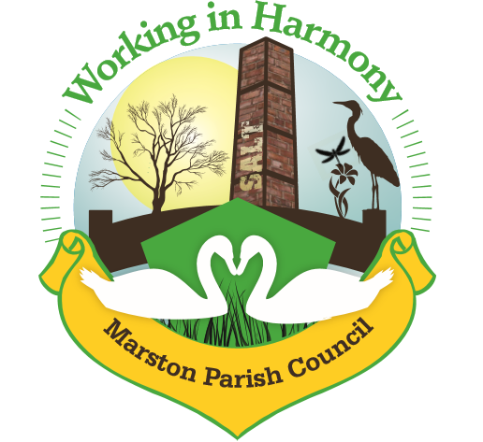
Minutes of Marston Parish Council meeting held on 11th November 2020
This meeting was held virtually using Google Meet
All councillors were sent an invitation email at 6.30pm with a link to ‘Join’ the meeting. Clerk ran the meeting and accepted all join requests
The meeting opened at 19:00
Present:
Parish Cllrs; Chairman M Potts (MP), Amanda Nixon (AN), Warren Davies (WD), Chris Anthwal (CA), Dave Collier (DC), Phil Carter (PhC)
Clerk; Caroline Constable (CC)
Ward Cllrs ; Phil Marshall
Apologies:
No apologies received.
Declarations of interest:
There were no declarations of interest
Dispensations:
There were no dispensations
Public Forum:
There were no requests from the public to join the meeting

Minutes:
The minutes from the parish council meeting of 21/10/2020 were agreed and approved.

 | Agenda Point | Assigned to..
1 | Parish Cllr Reports  Clerk – emailed received early afternoon from a resident highlighting issue over secure passwords. They had not been aware that their passwords were weak and asked that we highlight online users need to create secure passwords especially in light of scams etc… All agreed to put a notice in next edition of MM | CC
2 | Ward Cllr Reports  PM –  Highlighted a number of consultations currently available for comment:  Budget 2021 – Main points looking at council tax and business rates for 2021 especially in respect to current financial issues due to COVID-19. Noted that most of the councils expenditure due to COVID-19 has been covered by government grants. PM requested that if we have any comments that we also copy in ward cllrs.  Walk Thrive – consultation looking at active travel. There was a consultation in the summer highlighting new walking/cycling routes (mostly Chester centric) but non had been added for Marbury. More funding is available, again any comments to be copied in to ward cllrs.  Short Break Strategy – looking at SEN children’s time away from families.  Planning White Paper – consultation now complete. CW&C comments to be sent via LG. Time is needed to compile all national feedback so results may not be available for some time.  COVID Board – public sessions are being held to talk about recovery plans. A Pandemic Scrutiny Committee was set up in the summer and reports sent to cabinet with recommendations for future support of individuals/communities and businesses  Sustainable Transport Panel – first public session to be held on 12/12 but may be Chester centric to start, but plans should filter out to other areas. Access via invite only, emails to be sent to Transport Strategy at CW&C.  Town & High Street Commission – report generated for regeneration of the high street, sent to cabinet.  Eddie Stobart development – Stobart had applied for planning permission for transport hub near Appleton. Council had refused and it had been taken to appeal. Secretary of State upheld refusal.  Members Budget Grants – grants still available for small projects  Wd Cllr’s Surgeries – first surgery is being planned for 1/12. LG to send details, need to communicate them to residents. | ALL  ALL  ALL
3 | Progress Reports  - Cenotaph  MP – Reverend Alec had emailed requesting details of Stone Mason and plans for repair for architect. Clerk to send details.  Evergreen Arch a success, to be taken down by 15/11. Northwich Guardian been in touch there may be an article in future publication. Facebook page gained 20-30 more followers due to exposure and Centenary information  - Marston Murmurs  Clerk – email from Alison Hamlin Hughes requesting advertising space for sale of her Marbury 2021 Calendar. WD highlighted use of back page (colour). Agreed to offer back page for one edition at £25, payable in advance. Clerk to contact with proposition.  WD – commented on The Salt Barge who are struggling due to lockdown. Plans to start take out meals again in next week or so. PC should be supporting – perhaps offer a free advert. WD to speak to Sarah. Also commented on the fact that many residents will again be suffering due to lockdown, need to highlight our COVID Support Group. WD to provide article for MM.  Clerk – requested that all cllr’s get some information to her by 20/11 so that the edition can be printed and distributed before end of the month. MP stated that she had requested positive comments about receipt of the newsletter prior to the start of the month – need to continue being organised in getting it out in time.  - Tour&Store Waste Water Management  Mr Yoxhall had claimed that there was no need for a management plan as no waste water being generated. Enforcement took this at face value and have accepted that it is not needed. PC contacted Wd Cllr’s asking that they look into this as PC believes that it is needed as run off from land seems to be contaminating the water course. LG contacted enforcement but so far no further information.PM to chase.  CA – in light if all of the issues with Northwich Metals CA commented on the fact that they are operating a Skip Hire business from the premises yet permission was denied some 5-6 years ago. It seems that they operate irrespective of planning consent. MP to ask planning to look into this. | CC  CC  WD  PM  PM
4 | Finance  Invoices received & cheques created:  - Clerks Purchases and Expenses - £72.09  Clerks Salary 24.67 @ £15.41ph - £380.11  Total payable £452.20 Chq no. 1261  - Williams Design & Print newsletter November £115.20 chq no. 1260  - Itseeze monthly payment for website £54 (November)– collected by direct debit  - CW&C members grant remittance for website build £540  - Remembrance Wreath chq no.1262 £70  Rent received (via Cllr CA):  No rent  Cleaner  3 weeks 25/10-8/11 £30  Invoices received from Bookings agent  7 weeks 6/9-18/10 £70  £60 chq to Cllr CA chq no. 1263  Signatories  Due to imminent resignation of WD cheque signatories need to be reviewed. All agreed to remove WD and add clerk as signatory. Clerk stated that it can now be done online, a letter is needed signed by current signatories (CA & MP). Clerk to create letter and action. | CC
5 | Correspondence  - Ashwood Park Neighbourhood Watch Scheme – email from Julia Griffiths highlighted setting up of scheme. She had also asked about a scheme that had been set up for Ollershaw Lane. Resident running that has now left the area and so it has been shut down. Notice to be placed in MM highlighting Ashwood Park Scheme and suggesting that any other residents interesting in setting up their own scheme do so.  - Alison Hamlin Hughes – email from resident asking whether she could advertise her Marbury 2021 calendar in MM. All agreed (see previous point 3b). | CC
6 | Any other business  No further business

Confirmed date of next meeting: 13/01/21

Meeting closed at 19:39

Abbreviations: pc (parish council), cllr (councilor), cllrs’ (councillors’), cllr’s (councillor’s), CW&C (Cheshire West and Chester), MM (Marston Murmurs), MPC (Marston Parish Council), TC (Town Council)

