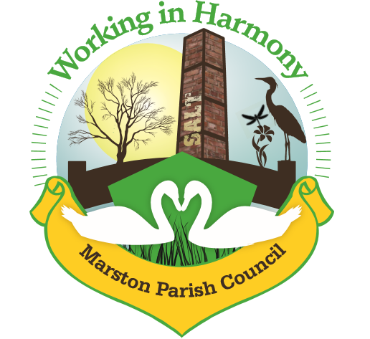
Minutes of Marston Parish Council meeting held on 13th October 2021

The meeting opened at 18:54

Present:
Parish Cllrs; Chairman M Potts (MP), Phil Carter (PhC), Amanda Nixon (AN), Angela Johnson (AJ), Ian Stanley (IS), Julie Ledger (JL) and Dave Collier (DC)

Ward Cllrs: Norman Wright (NW)

Clerk: Caroline Constable (CC)

Apologies:
Apologies received from Ward Cllrs Lynn Gibbon (LG) and Phil Marshall (PM)

Declarations of interest:
There were no declarations of interest
Dispensations:
There were no dispensations
Public Forum:
There were no public present

Minutes:
The minutes from the parish council meeting of 08/09/2021 were agreed and approved.

Actions from previous meeting:

 | Action | Assigned to | Actioned
1 | Create an alert on planning system | CC | To be done
2 | Send application to Fiona Dunning for interactive speed device | CC | √ grant awarded
3 | Contact highways about flagging & fencing around heritage signpost | CC | √ see agenda point 3.c. & correspondence
4 | Email Wincham PC regarding Neighbourhood Plan | CC | √ see agenda point 3.d.
5 | Renew electricity tariff | CC | √ 2 year fixed @0.3353 pd 0.2097 kwh
6 | Respond to resident regarding broadband provider | CC | √
7 | Add policy reviews to next month’s agenda | CC | √
8 | Send letter to Mr Gibbon regarding hedgerows | CC | √ no reply
9 | Contact Miles about the fire alarm board | CC | √ 4 new sensors ordered

 | Agenda Point | Assigned to..
1 | Parish Cllr Reports  Cllr MP – Issues with verges on Fernlea Road. Tenant on Mere Road has put barriers in in form of plants and handrail and is claiming it as their own. Numerous complaints from other residents. Issue has been reported to Weaver Vale, CW&C & Police (due to abusive language directed at councillor by tenant). Awaiting report from various authorities.  Cllr MP – trees are being planted by residents along land adjacent to Higher Marston Play area, this will impact grass cutting. Report sent to CW&C, awaiting response from Tree Manager.  Cllr IS – Issue with flooding on Marston Lane at crossroads with Darke Lane and Ollershaw Lane. Cllr MP advised that drainage issues have been reported to CW&C in past but that issue also due to overgrown verges and gutters full of debris. Clerk to contact CW&C (copy Ward Cllr NW) | CC
2 | Ward Cllr Reports  Ward Cllr NW – £3000 ward councillor grant now awarded for purchase of interactive traffic sign. A meeting with Andy Hammond now required to finalise details. Clerk to contact (copy in Ward Cllr NW) | CC
3 | Progress Reports  - Interactive Traffic Speed Sign  Grant for partial payment now authorised (£3000). Meeting with Highways to be arranged to discuss positioning/type. On point of current traffic issues, clerk raised the fact that the Salt Museum are currently having the walls repointed along the roadside down from the traffic lights. Is this due to erosion or vibrations from traffic? Clerk to contact Salt Museum to determine. If it is an issue with vibrations it may help with case of getting HGV’s banned from using Ollershaw Lane.  - Cenotaph Repair  Clerk to chase contractor. On point of Remembrance Sunday; it was agreed that the Evergreen Arch is to be erected on Saturday 6th November (notice to be put in MM for volunteers and evergreen greenery. Lamppost poppies also to be placed. Clerk to put notice in MM. Clerk to purchase 1 large and 2 small wreaths and Cllr MP to contact RBL  - Heritage Signpost  Contractor has now almost completed the repair. With regards to flagging and fencing around the post it was agreed that this should be done, perhaps with gravel rather than flags. Clerk to look for contractor.  - Neighbourhood Plan  Wincham PC pulling out due to lack of committed councillors. All agreed that it was still something that needed doing and Cllr’s IS, AJ & JL agreed to get involved. Ward Cllr NW pointed out that CW&C offered support. Clerk to contact CW&C. Clerk also to put notice in MM asking for residents to get involved. | CC  CC  CC  MP  CC  CC  CC
5 | Finance  Invoices received & cheques created:  - Clerks Purchases and Expenses - £46.69  Clerks Salary hrs 27.75 @ £15.41ph - £427.63  Total payable £474.32 Chq no. 1307  - Itseeze website/email September @ £57  - Williams Design & Print – newsletter £119.00 chq no. 1304  - Pat Testing Eric Johnson – chq no. 1305  - Cleaner – 29/8/21 – 10/10/21 7 weeks £70  - Booking Agent – 29/8/21 – 10/10/21 7 weeks £70  £140 in total paid to Angie chq no. 1308  - Rent:  Mark Spruce – The Penguin Group band practice – 14/9 £17 paid £20, 27/9 £34 paid £35, 28/9 £17 paid £20, 22/9 £17 paid £20, 4/10 £17 paid £20, 6/10 £25.50 paid £25  Julia Griffiths - £17 paid £17  Total £157  - Daffodils for traffic triangle. £36.00 Chq no. 1309 to Cllr AN
6 | Correspondence  - Email from Steven Bentley regarding tidying up around fingerpost  - Email from Keep Fundraising regarding publishing an article in MM – agreed that advertising of fundraising activities not required  - Email from chalc regarding planning training  - Email from chalc regarding list of available courses from partners Breakthrough Communications  - Email from Cheshire action regarding COVID winter plan for community buildings – pc to continue with current risk assessments and advice  - Email from chalc regarding questionnaire for impact of covid-19 on businesses – clerk to complete  - Email from creative lives regarding microgrants for creative projects  - Email from chalc regarding speeding issues consultation first draft news release – agreed that pc would sign up to this. Clerk to contact  - Email from Keep Britain Tidy regarding glow in the dark signs for ‘Dark Nights = Dog Poo Increase’ – agreed not necessary  - Planning Application 21/03791/FUL – erection of detached dwelling next to 4 Cross Street – submission of change to dwelling style – clerk advised that changes to style included 2 storey to 3 storey with master bedroom now in roof space with roof velux windows and slight changes to front of property – all agreed that further comments would be futile as planning already consented and changes would not impact current residents | CC  CC
7 | Any other business  Cllr MP – Macmillan Coffee morning well attended, donations not yet finalised but in excess of £200

Confirmed date of next meeting, 10/11/21

Meeting closed at 20:30

Abbreviations: pc (parish council), cllr (councillor), cllrs (councillors), cllrs’ (councillors’), cllr’s (councillor’s), CW&C (Cheshire West and Chester), MM (Marston Murmurs), MPC (Marston Parish Council)

