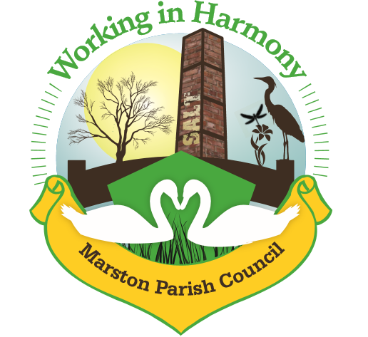
Minutes of Marston Parish Council meeting held on 9th October 2019
The meeting opened at 19:00
Present:
Parish Cllrs; Chairman M Potts (MP), Phil Carter (PhC), Amanda Nixon (AN), Dave Collier (DC) and Chris Anthwal (CA)
Clerk; Caroline Constable (CC)
Apologies:
Apologies were received from Parish Cllrs; Warren Davies (WD) and Iain Stead (IS) and Ward Cllrs; Lynn Gibbon (LG), Norman Wright (NW)
Apologies were accepted
Declarations of interest:
Cllr MP expressed an interest in the Planning Application 19/02174/FUL as she uses land that the applicant owns.
Dispensations:
There were no dispensations
Public Forum:
There were no members of the public present.

Minutes:
The minutes from the parish council meeting of 11/09/19 were agreed and approved.

Actions from previous meeting:

Action | Assigned to | Actioned
Cash Monies/Send Cheques | CC | √
Investigate importing pc emails into gmail | CC | Carry forward
Write notice for MM re Keep fit in hall & contact PT | WD | Carry forward
Purchase Bulbs | CC | √
Ask Vicar about the Church Hall Key | WD | Carry forward
Provide further info about SLCC membership | CC | √ - cllr’s agreed that clerk should sign up to the membership
Email Wincham pc requesting update on Neighbourhood plan involvement | CC | √ meeting to be scheduled
Look into funds for bridge (Urban Village) & contact cw&c regards establishing a public right of way (forebrook bridge) | LG | Carry forward
Contact cw&c regarding Hall Drive, Bus stop opposite Hall Drive, Hedges/steps between Fernlea Road and Mere Road | LG/NW/PM | Carry forward
Winnington bridge – update on funding | LG | Carry forward
Update Financial Standing Order | CC | √
Email Ward Cllr LG – recharge may election | CC | √
Objection to planning application 19/02819/FUL | CC | √
Reorder agenda items | CC | √

 | Agenda Point | Assigned to..
1 | Parish Cllr Reports  It was decided that due to lack of interest in recent years that the PC would not be holding a Christmas Fayre this year. New events for future will be discussed early next year.  The Christmas Signing Evening would still be going ahead on 13th December as planned. Notice to be placed in MM.  Clerk advised that the farmer had not yet been contacted to request consent for placing LPG tank on car park for central heating. Clerk will contact.  Cllr MP raised an issue that a resident had raised at the last coffee morning – they were concerned with the state of a neighbour’s hedge asking why the council couldn’t do anything about it such as make them cut it back. Clerk advised that PC does not have jurisdiction over this, if the property is rented then resident should go to the landlord if they have not been able to get the neighbour to cut it back themselves.  Cllrs MP and DC had been asked by a number of residents why October’s MM had not yet been delivered. Distribution of workload for creation of MM will be added to next month’s agenda  Cllr MP – raised the question of repairs to the Cenotaph. Cllr’s believe that it is the responsibility of everyone to maintain war memorials and so PC will possibly have to cover costs of repair. Clerk to look into getting it repaired before Remembrance Sunday.  Clerk also to contact Royal British Legion regarding Remembrance Sunday service. Article needed for next MM - clerk will update with times. | WD  CC  CC  CC  CC  WD/CC
2 | Ward Cllr Reports  No Ward cllrs were present.  Ward cllr NW had telephoned clerk to give absence notification and update on Northwich Metals Tour&Store planning application – the application will be going to the planning committee early November and PC should liaise with MaRCH to coordinate their 3 minute input. The planning officer would be recommending Approval with conditions.  A meeting with MaRCH is to be arranged | CC
3 | Progress Reports  - Ceiling/Roof in Hall  Cllr WD not present – carry forward  - Lobbying of Canal & River Trust re allotments  No update on this matter  - Printer Cupboard  Cllr WD not present – carry forward  - Alteration of Noticeboard for LSW  Still in progress; dependant upon item 1.c  - Central Heating  Clerk advised that unable to obtain third quote. With consensus of cllr’s it was agreed that we could progress with the two quotes already received. Clerk to contact necessary companies/tradesmen to get the project progressing. Clerk also advised that she had submitted an application to the current Members Budget Award Scheme for a grant towards the costs. Current quote for boiler and radiators alone is £5790 plus VAT.  - Neighbourhood Plan  Clerk has been in contact with Wincham PC to organise a further meeting. Awaiting their response.  - Forgebrook Bridge  No further information. Awaiting update from Ward Cllr LG. | CC
4 | Finance  - To sign off changes to financial regulations – unfortunately Clerk misplaced document – will be carried forward for next meeting  - Accept/signoff bank reconciliations – Cllr DC checked bank reconciliations and signed off  - Discuss/agree day rate for hall hire – it was agreed that for future hires of 6 hours and over a 10% discount would be applied. Clerk to update website and inform Angie.  - Electricity renewal – Clerk advised that current fixed rate due to end 31/10/19. Negotiated a new 2 year contract that whilst slightly more than current rate is less than standard rate. If current bill charged under new rates, current bill would have increased by approximately £2.  Invoices received & cheques created:  - Clerks Purchases and Expenses - £ 107.32  Including envelopes £2.99, paper £4.99, stamps £16.80, printer cartridges £44.22  Clerks Salary 26.69 hours @ £15ph - £400.35  Total payable £ 507.67 Chq no. 1213  - Scottish Power - £102.80 taken 30/9/19  - Waterplus - £11.97 taken 13/9/19  - CW&C – Recharge £90.50 (half of the bill – remainder to be charged next year) chq no. 1212  - Williams design and print – printing of newsletter – October - £133.20 chq no. 1214  Rent received (via Cllr CA):  - Mark – Band £40  - Harley&Dutch – Bank £25.50  - Graeme - £17.50 (although only £17 received)  Invoices received from Cleaner  4 weeks (15/9 – 6/10) £40  Invoices received from Bookings agent  4 weeks (15/9 – 6/10) £40  Cheque for £80 created for Cllr Anthwal chq no 1215 | CC  CC
5 | Correspondence  - Planning Consultation 19/03509/LDC - Crystal Cottage - Use of land for storage of building materials and equipment – Cllr’s concerned that large swath of land seems to be included in the application for the storage of machinery and as application does not detail actual storage requirements this could result in excessive storage and destruction within the conservation area. Cllr CA to investigate further and liaising with Clerk an objection will be placed as soon as possible  - Proposed 20 mph speed limit Marston Parish – Higher Marston – no objections to proposal  - Planning Consultation 19/03534/FUL - End Cottage - Single storey rear extension – no objections to application  - Planning Consultation 19/02174/FUL – Murmansk – erection of one dwelling (replacement) – amendment to application 19/00787/FUL – Clerk detailed revisions – no objection to application | CA  CA/CC
6 | Completion of Enforcement Policy Consultation  Document completed. Clerk will post | CC
7 | Any other business  No other business

Confirmed date of next meeting, 13/11/19

Meeting closed at 20:50

Abbreviations: pc (parish council), cllr (councilor), cllrs’ (councillors’), cllr’s (councillor’s), CW&C (Cheshire West and Chester), MM (Marston Murmurs)

