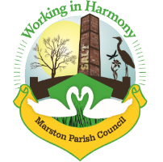

Marston Parish Council meeting 21st April 2021
Agenda
Apologies for Absence: To receive apologies and approve reasons for absence
Declarations of interest: Register of interests - Councillors are reminded of the need to update their register of interests and the need to disclose both the type of interest and its nature
Dispensations: To consider requests for Dispensations
Public Forum: Electors and members of the public are welcome to raise their issues or present matters of interest to the council
Minutes: To consider the approval of the minutes of the last meeting of the Council

Actions from last parish council meeting

- Parish Councillors’ reports and items for future agendas
Each Councillor is requested to use this opportunity to report minor matters of information not included elsewhere on the agenda
- Ward Councillor Reports
For information only, items raised for discussion will appear on the agenda for the next meeting
- Progress Reports
  - Scarecrow Competition
  - Heritage Signpost
  - Cenotaph Repair
  - Tarmacking Hall Carpark
  - Fire door
  - Reopening of Hall
- Finance
- Accounts signoff
- 2020-2021 Accounts
- Adding Cllr Nixon as signatory, removing Chris Anthwal
- To consider payments to be made as per attached list
- Correspondence
To note correspondence received as per attached list
- Re-start of face-to-face Meetings
- Police & Crime Commissioner Election
- Any other business
To note any other business arisen during discussions

Date of the next meeting. 12/05/21

