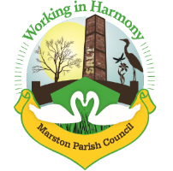

Marston Parish Council meeting 16th September 2020
Agenda
Apologies for Absence: To receive apologies and approve reasons for absence
Declarations of interest: Register of interests - Councillors are reminded of the need to update their register of interests and the need to disclose both the type of interest and its nature
Dispensations: To consider requests for Dispensations
Public Forum: Electors and members of the public are welcome to raise their issues or present matters of interest to the council
Minutes: To consider the approval of the minutes of the last meeting of the Council

- Parish Councillors’ reports and items for future agendas
Each Councillor is requested to use this opportunity to report minor matters of information not included elsewhere on the agenda
- Ward Councillor Reports
For information only, items raised for discussion will appear on the agenda for the next meeting
- Progress Reports
  - Cenotaph
  - Website
- Finance
  - Accounts sign off July-September
  - To consider payments to be made as per attached list
  - 2020-2021 National Salary Award for employees – to discuss increasing clerk’s salary in line with award
- Correspondence
To note correspondence received as per attached list
- Re-opening of Church Hall
To consider the reopening of the church hall for public use, including risk assessment
- Evergreen Structure & Pathway
To discuss the funding of the evergreen structure to help commemorate Centenary of Cenotaph
- Any other business
To note any other business arisen during discussions

Date of the next meeting. Due to current COVID-19 issues next meeting not scheduled. Discuss future schedule

